

Centre Name: **FPT – APTECH**

*590 Cách Mạng Tháng Tám St, 3th Dist, HCMC - Tel: (08) 3 846 0 846*

**Work To Worker**

**Development’s Guide**

**Faculty: Ngo Phuoc Nguyen**

**Batch No: F2-10-1203-T0**

**Group No: 4**

**Student:**

|  |  |  |
| --- | --- | --- |
| **No** | **Full Name** | **Roll No** |
| **1** | **Trinh Cong Thanh** | **Student639923** |
| 2 | Nguyen Chi Tan | Student639909 |
| 3 | Hong Lam Son | Student636685 |
| 4 | Phan Trong Nhan | Student639896 |

**REVIEW 1**

**PROBLEM DEFINITION**

1. **Introduction**

Objective of this system is to providing a work to worker. Solution focused on the workers of unorganized sector includes mason, carpenters, gardener, painter etc. Work to Worker is a Web-based solution through which worker (s) registered themselves for a specific skill. Using this system general public or organized sector user can select the worker(s) as per their need. At the time of worker selection he/she can view the skill, references given by those who have taken their service in the past, area (worker location) and availability of a particular worker(s). System sends SMS to a selected worker(s) regarding work and customer details. Worker(s) confirms either through phone or this system and either fixed up meeting or work start date. Organized sector user or general public can rate worker skill, charges, particularity about time, dedication, behavior, habits etc through this system. Users can put their demands regarding particular skill workers along with project location, and project details.

1. **Existing Scenario**

How worker to find a suitable job? or How recruiters to employ workers to work for them?

There are many ways to answer these question: You can go to the centre of training and labour services or go to the office recruitment ect… but the problem is that when anyone walks into the office, they are required to fill an enquiry form with many of informations and then waitting for result ect...

But as the business is expanding day by day, so we have decided to reach the people through web-site.

**CUSTOMER REQUEST**

**SPECIFICATION**

1. **Customer Requirement Specification**

A site needs to be designed where user will register either as a worker(s) or customers (general public/ organize sector user).

If registered as a worker then they will be able to update their own profile and go through the site to view the informations about other workers or recruiters.

If registered as a customer, they can update their own profile and go through the site to view the informations about other recruiters or workers. They can also choose the worker and then group them as a group that they need.

A user can also access to the website as a guest. If a user using a guest account they can only view the information at some permission areas.

1. **User of the system**

* Administators
* Worker on from unorganized sector
* Customer – Organized sector (builder, constructor)
* General public

1. **Functional Requirement Specification**

* Secure Registration of users (workers) and customers (general public/ organize sector user) with any type of centralized security mechanisms (election card, passport, pan card etc.).
* Workers are classified into various groups & categorized namely aware skilled, semiskilled, etc...
* State can be modified by feedback system & workers rating evaluation algorithms.
* Profile management facilities for both laborers and customers.
* Chat/mail/SMS services (preferably multilingual).
* Customer can make a community for reference purpose etc.
* Customer can give their feedback for worker(s) who worked for them.
* Worker can view details information project (organized sector) in particular location.
* Worker can maintain the work calendar which should be exported to txt; xls or pdf format, there must be mechanisms for face-to-face meeting with customer.
* Local language support.
* Administrator able to generate various reports graphs on strategic data which should be exported on xsl or csv format, also able to backup/recovery data.
* Facilitate appropriate communication between all stakeholders - Discussion forum/chat/mail/polls.
* User Manual.

1. **Requirements for users of the system**

* **Requirements for website administrator**
  + **Input**
* Login information: username and password
* Information for changing their own profile
* Information for viewing and deleting worker’s, general public’s organized sector’s profile
* Feedback and technical support content
* The type of report and the locale path
  + **Output**
* Information about each finished task
* Information about worker, general public, organized
* Information of the report
  + **Process**
* Check login information
* Check valid input information
* Check entities integrity
* Maintaining report
* **Requirements for worker**
  + **Input**
* Login information: username and password
* Information for changing or viewing their own profile
* Information for viewing other worker’s, general public’s organized sector’s profile
* Choose the type of report
  + **Output**
* Information about each finished task
* Information about worker, general public, organized
* Information of the report
* Technical support content
  + **Process**
* Check login information
* Check valid input information
* Check entities integrity
* Maintaining report
* **Requirements for Customer – Organized sector**
  + **Input**
* Login information: username and password
* Information for changing or viewing their own profile
* Information for viewing other worker’s, general public’s or other organized sector’s profile
* Feedback to administator or any organization they work for
* Information for viewing the administator or worker
* Choose workers to work for
* Choose workers to grouping them as a group
* Choose the type of report
  + **Output**
* Information about each finished task
* Information about worker, general public, organized
* Information of the report
* Technical support content
* Information about admin’s or worker’s feedback
  + **Process**
* Check login information
* Check valid input information
* Check entities integrity

Maintaining report

* **Requirements for General public**
  + **Input**
* Login information: username and password
* Information for changing or viewing their own profile
* Information for viewing other worker’s, other general public’s organized sector’s profile
* Feedback to administator or any organization they work for
* Choose the type of report
* Information for viewing the administator or worker
  + **Output**
* Information about each finished task
* Information about worker, general public, organized
* Information of the report
* Information about admin’s or worker’s feedback
* Technical support content
  + **Process**
* Check login information
* Check valid input information
* Check entities integrity

1. **Technology**

* PrimeFace Framework
* JavaServer Face Framework
* J2EE
* JSP, Servlet
* HTML
* EJB

1. **System Requirement**

* **For Users**
  + **Hardware**
    - CPU: Pentium IV 2.0 GHz or higher
    - RAM: 512 MB or higher
  + **Software**
    - OS: Windows XP Professtional, Windows Vista, Windows 7, Windows 8
    - Browser: Internet Explorer 7.0 or higher, FireFox, Chrome
* **For Software Developers**
  + **Hardware**
    - CPU: Pentium IV 2.0 GHz or higher
    - RAM: 1024 MB or higher
  + **Software**
    - OS: Windows XP Professtional, Windows Vista, Windows 7, Windows 8
    - Netbeans 7.3
    - JDK 1.7
    - Microsoft SQL Server 2008
    - PrimeFace Framework
    - GlassFish Server
    - Browser: Internet Explorer 8.0 or higher, FireFox, Chrome

|  |  |  |
| --- | --- | --- |
| **Date: Oct 3rd, 2013** | **Prepared by Project Group 4**  **Team Leader: Trinh Cong Thanh** | **Approved by**  **Mr : Ngo Phuoc Nguyen** |
| **Signature** |  |  |

**REVIEW 2**

1. **Use Case and Sequence Diagram**

**7.1 Guest**

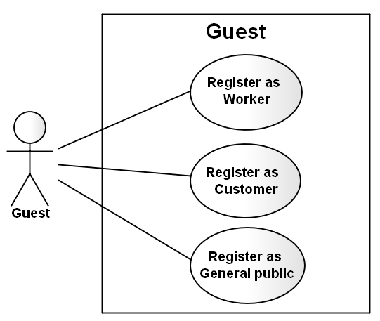

**7.1.1 Register as Worker**

|  |  |  |
| --- | --- | --- |
| **Author** | Nguyen Chi Tan | |
| **Use Case Name** | Register as Worker | |
| **Actors** | Guest | |
| **Description** | Guest wants to register with the website to become a worker member. | |
| **Requirements** | Guest provides Guest’s information | |
| **Pre-conditions** |  | |
| **Post-conditions** | Success: Guest creates a Worker account in this website  Fail: Refill information | |
| **Basic flow** | Actor Actions:  1. Actor clicks ‘Register’ link in Home page  3. Actor Input information and click ‘Complete Registration’ button. [Alternative 1] | System Responses:  2. System redirects to Registration page.  4. System redirects to Register page and displays Registration form with the following control :  - ‘UserName’ text field  - ‘Password’ text field  - ‘Confirm new Password’ text field  - ‘FirstName’ text field  - ‘LastName’ text field  - ‘Gender’ checkbox group  - ‘Birthday’ text field  - ‘Address’ text field  - ‘Phone’ text field  - ‘Email’ text field  - ‘ProofID’ text field  - ‘SecurityQuestion’ text field  - ‘SecurityAnswer’ text field  - ‘Complete Registration’ button  - ‘Cancel’ button  6. System checks the information  [Exception 1]  7. System inserts the account into database, show message: ‘Your account has been created!’ and then redirects to Login page. |
| **Alternative flow** | Actor Actions:  [Alternative 1]  1. Actor click ‘Cancel’ button. | System Responses:  2. System returns to Home page. |
| **Exception** | Actor Actions:  [Exception 1]   1. Actor lefts ‘UserName’ text field blank 2. ‘UserName’ has already existed 3. Actor lefts ‘Password’ text field blank. 4. Confirm Password’ text field blank. 5. Password and Confirm Password doesn’t match. 6. Actor lefts ‘FirstName’ text field blank. 7. Actor lefts ‘LastName text field blank. 8. Actor lefts ‘Birthday’ datebox blank. 9. Age less than 16 10. Actor lefts ‘Address’ text field blank. 11. Actor lefts ‘Phone’ text field blank. 12. Actor Input phone number is not digits or the length of phone number does not in range 8 – 15 digits. 13. Actor lefts ‘Email’ text field blank or input an invalid email address. 14. Actor lefts ‘ProofID’ textfield blank 15. Actor Input ‘ProofID’ is not digits or the length of phone number does not in range 9 – 12 digits. | System Responses:  System displays message to Actor :  - ‘UserName cannot be blank’.  - ‘This UserName has already existed !  - ‘Password cannot be blank’.  - ‘Confirm Password can’t be blank’.  - ‘Confirm Password doesn’t match.’  - ‘FirstName cannot be blank’.  - ‘LastName cannot be blank’.  - ‘Birthday is invalid’.  - ‘Age must over 16’.  - ‘Address cannot be blank’.  - ‘Phone is invalid’.  - ‘Just input digits. The length of phone number from 8 to 15’.  - ‘Email is invalid’.  - ‘ProofID cannot be bank’  - ‘Just input digits. The length of ProofID from 9 to 12’. |

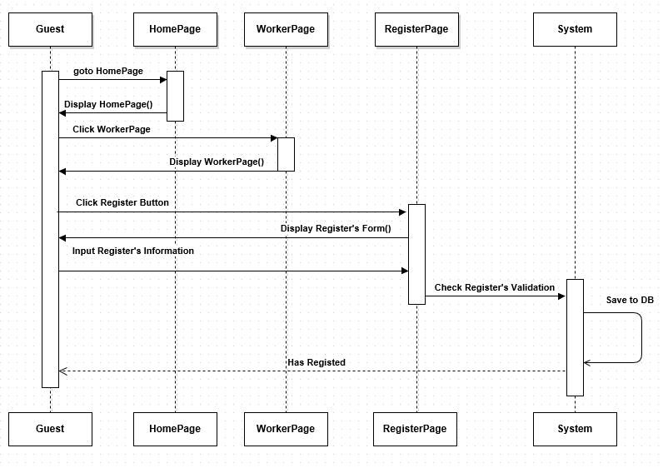

**7.1.2 Register as Customer**

|  |  |  |
| --- | --- | --- |
| **Author** | Trinh Cong Thanh | |
| **Use Case Name** | Register as Customer | |
| **Actors** | Guest | |
| **Description** | Guest wants to register with the website to become a customer member. | |
| **Requirements** | Guest provides Guest’s information | |
| **Pre-conditions** |  | |
| **Post-conditions** | Success: Guest creates a Customer account in this website  Fail: Refill information | |
| **Basic flow** | Actor Actions:  1. Actor clicks ‘Register’ link in Home page  3. Actor Input information and click ‘Complete Registration’ button. [Alternative 1] | System Responses:  2. System redirects to Registration page.  4. System redirects to Register page and displays Registration form with the following control :  - ‘UserName’ text field  - ‘Password’ text field  - ‘Confirm new Password’ text field  - ‘FirstName’ text field  - ‘LastName’ text field  - ‘Gender’ checkbox group  - ‘Birthday’ text field  - ‘Address’ text field  - ‘Phone’ text field  - ‘Email’ text field  - ‘ProofID’ text field  - ‘SecurityQuestion’ text field  - ‘SecurityAnswer’ text field  - ‘Complete Registration’ button  - ‘Cancel’ button  6. System checks the information  [Exception 1]  7. System inserts the account into database, show message: ‘Your account has been created!’ and then redirects to Login page. |
| **Alternative flow** | Actor Actions:  [Alternative 1]  1. Actor click ‘Cancel’ button. | System Responses:  2. System returns to Home page. |
| **Exception** | Actor Actions:  [Exception 1]   1. Actor lefts ‘UserName’ text field blank 2. ‘UserName’ has already existed 3. Actor lefts ‘Password’ text field blank. 4. Confirm Password’ text field blank. 5. Password and Confirm Password doesn’t match. 6. Actor lefts ‘FirstName’ text field blank. 7. Actor lefts ‘LastName text field blank. 8. Actor lefts ‘Birthday’ datebox blank. 9. Age less than 16 10. Actor lefts ‘Address’ text field blank. 11. Actor lefts ‘Phone’ text field blank. 12. Actor Input phone number is not digits or the length of phone number does not in range 8 – 15 digits. 13. Actor lefts ‘Email’ text field blank or input an invalid email address. 14. Actor lefts ‘ProofID’ textfield blank 15. Actor Input ‘ProofID’ is not digits or the length of phone number does not in range 9 – 12 digits. | System Responses:  System displays message to Actor :  - ‘UserName cannot be blank’.  - ‘This UserName has already existed !  - ‘Password cannot be blank’.  - ‘Confirm Password can’t be blank’.  - ‘Confirm Password doesn’t match.’  - ‘FirstName cannot be blank’.  - ‘LastName cannot be blank’.  - ‘Birthday is invalid’.  - ‘Age must over 16’.  - ‘Address cannot be blank’.  - ‘Phone is invalid’.  - ‘Just input digits. The length of phone number from 8 to 15’.  - ‘Email is invalid’.  - ‘ProofID cannot be bank’  - ‘Just input digits. The length of ProofID from 9 to 12’. |

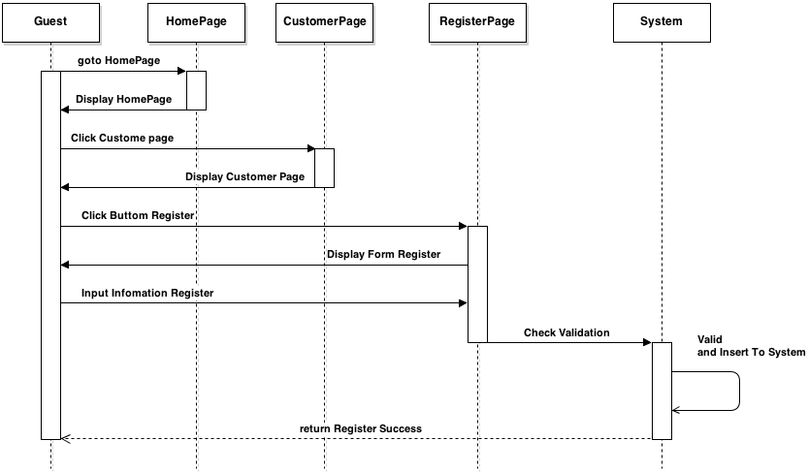

**7.1.3 Register as General Public**

|  |  |  |
| --- | --- | --- |
| **Author** | Hong Lam Son | |
| **Use Case Name** | Register as General public | |
| **Actors** | Guest | |
| **Description** | Guest wants to register with the website to become a general public member. | |
| **Requirements** | Guest provides Guest’s information | |
| **Pre-conditions** |  | |
| **Post-conditions** | Success: Guest creates a General Public account in this website  Fail: Refill information | |
| **Basic flow** | Actor Actions:  1. Actor clicks ‘Register’ link in Home page  3. Actor Input information and click ‘Complete Registration’ button. [Alternative 1] | System Responses:  2. System redirects to Registration page.  4. System redirects to Register page and displays Registration form with the following control :  - ‘UserName’ text field  - ‘Password’ text field  - ‘Confirm new Password’ text field  - ‘FirstName’ text field  - ‘LastName’ text field  - ‘Gender’ checkbox group  - ‘Birthday’ text field  - ‘Address’ text field  - ‘Phone’ text field  - ‘Email’ text field  - ‘ProofID’ text field  - ‘SecurityQuestion’ text field  - ‘SecurityAnswer’ text field  - ‘Complete Registration’ button  - ‘Cancel’ button  6. System checks the information  [Exception 1]  7. System inserts the account into database, show message: ‘Your account has been created!’ and then redirects to Login page. |
| **Alternative flow** | Actor Actions:  [Alternative 1]  1. Actor click ‘Cancel’ button. | System Responses:  2. System returns to Home page. |
| **Exception** | Actor Actions:  [Exception 1]   1. Actor lefts ‘UserName’ text field blank 2. ‘UserName’ has already existed 3. Actor lefts ‘Password’ text field blank. 4. Confirm Password’ text field blank. 5. Password and Confirm Password doesn’t match. 6. Actor lefts ‘FirstName’ text field blank. 7. Actor lefts ‘LastName text field blank. 8. Actor lefts ‘Birthday’ datebox blank. 9. Age less than 16 10. Actor lefts ‘Address’ text field blank. 11. Actor lefts ‘Phone’ text field blank. 12. Actor Input phone number is not digits or the length of phone number does not in range 8 – 15 digits. 13. Actor lefts ‘Email’ text field blank or input an invalid email address. 14. Actor lefts ‘ProofID’ textfield blank 15. Actor Input ‘ProofID’ is not digits or the length of phone number does not in range 9 – 12 digits. | System Responses:  System displays message to Actor :  - ‘UserName cannot be blank’.  - ‘This UserName has already existed !  - ‘Password cannot be blank’.  - ‘Confirm Password can’t be blank’.  - ‘Confirm Password doesn’t match.’  - ‘FirstName cannot be blank’.  - ‘LastName cannot be blank’.  - ‘Birthday is invalid’.  - ‘Age must over 16’.  - ‘Address cannot be blank’.  - ‘Phone is invalid’.  - ‘Just input digits. The length of phone number from 8 to 15’.  - ‘Email is invalid’.  - ‘ProofID cannot be bank’  - ‘Just input digits. The length of ProofID from 9 to 12’. |

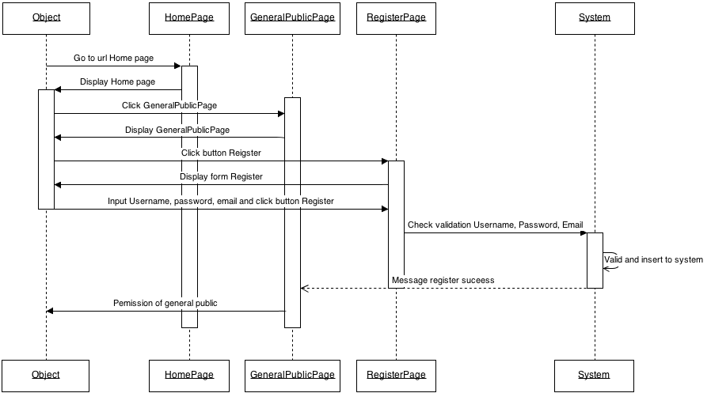

**7.2 General Public, Customer, Worker**

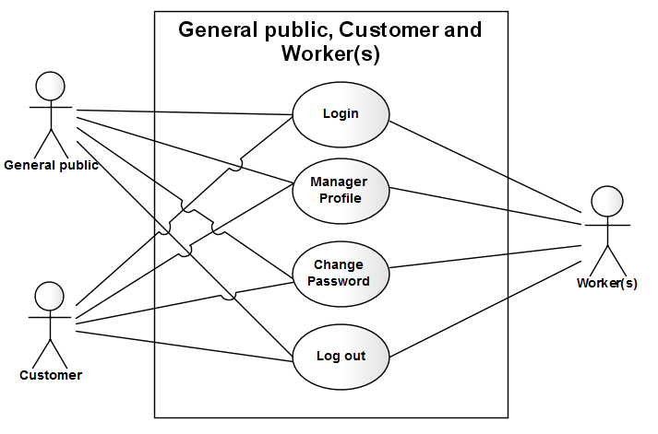

**7.2.1 Login**

|  |  |  |
| --- | --- | --- |
| **Author** | Trinh Cong Thanh | |
| **Use Case Name** | Login | |
| **Actors** | Custommer or General public or Worker | |
| **Description** | Custommer or General public or Worker wants to login to website as a Custommer or General public or Worker member. | |
| **Requirements** | Actor provides username and password | |
| **Pre-conditions** |  | |
| **Post-conditions** | Success: User logged in to website.  Fail: ReEnter the login information | |
| **Basic flow** | Actor Actions:  1. Actor go to Home page of website.  3. Actor input UserName and Password, then click the Login button. | System Responses:  2. System redirects to Home page and displays Login form on the left with the following control:  - ‘UserName’ text field  - ‘Password’ text field  - ‘Login’ button  4. System checks the information  [Exception 1]  5. System redirects to Actor’s Home page. |
| **Alternative flow** | Actor Actions:  [Alternative 2]  1. Actor click ‘OK’ button, input UserName and Password, then click the Login button.  [Alternative 1]  1. Actor click ‘Back to Home’ button. | System Responses:  2. System checks the information  [Exception 1]  3. System redirects to Actor’s Home page.  2. System returns to Home page. |
| **Exception** | Actor Actions:  [Exception 1]  1. Actor input invalid username and password. | System Responses:  - System redirect to Login page with the following controls:  - ‘UserName’ text field  - ‘Password’ text field  - ‘Login’ button.  - ‘Back to Home’ button.  System show a message box: “Invalid Username or password”.[Alternative 2] |

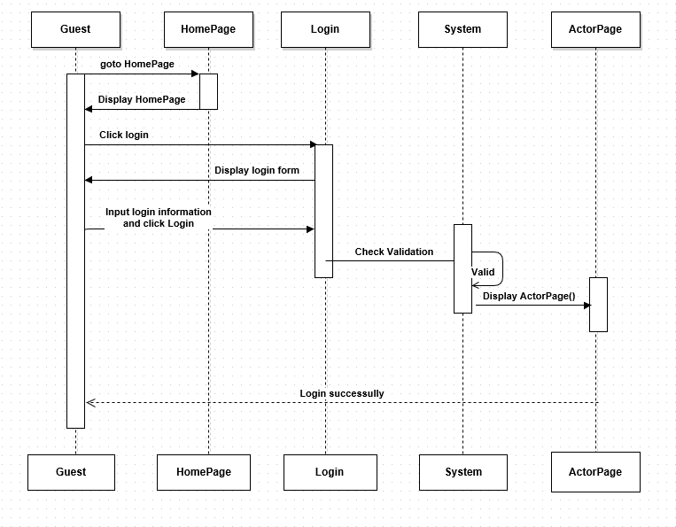

**7.2.2 Manage Profile and Change Password**

|  |  |  |
| --- | --- | --- |
| **Author** | Hong Lam Son | |
| **Use Case Name** | Update Profile and Change Password | |
| **Actors** | Custommer or General public or Worker | |
| **Description** | Custommer or General public or Worker wants to Update his/her profile’s information. | |
| **Requirements** | Actor provides profile information | |
| **Pre-conditions** | Actor has logged in. | |
| **Post-conditions** | Success: Profile’s information of this user has been updated.  Fail: Refill information | |
| **Basic flow** | Actor Actions:  1. Actor clicks ‘Profile’ button in Actor’s Home page menu.  3. Actor Input updates information and click ‘Save’ button. [Alternative 1] | System Responses:  2. System redirects to Update Profile page and displays Update Profile form with the following control :  ‘UserName’ text field (read only)  - ‘Old Password’ text field  - ‘New Password’ text field  - ‘Confirm new Password’ text field  - ‘FirstName’ text field  - ‘LastName’ text field  - ‘Gender’ checkbox group  - ‘Birthday’ text field  - ‘Address’ text field  - ‘Phone’ text field  - ‘Email’ text field  - ‘ProofID’ text field  - ‘SecurityQuestion’ text field  - ‘SecurityAnswer’ text field  - ‘Save’ button  - ‘Cancel’ button  4. System checks the information  [Exception 1]  5. System update the account into database and then redirects to Actor Home page. |
| **Alternative flow** | Actor Actions:  [Alternative 1]  1. Actor click ‘Back to Home’ button. | System Responses:  2. System returns to Home page. |
| **Exception** | Actor Actions:  [Exception 1]  1. Actor lefts ‘New Password’ text field blank.  2. Actor lefts ‘New Confirm Password’ text field blank.  3. New Password and New Password Confirm don’t match.  4. Actor lefts ‘FirstName’ text field blank.  5. Actor lefts ‘LastName’ text field blank.  6. Actor lefts ‘Birthday’ datebox blank.  7. Input age to ‘Birthday’ datebox less than 16.  8. Actor lefts ‘Address’ text field blank.  9. Actor lefts ‘Phone’ text field blank.  10. Input phone not in numeric or phone length not in range 8 – 15 character.  11. Actor lefts ‘Email’ text field blank or input an invalid email address.  12. Actor lefts ‘ProofID’ textfield blank  13. Input proofID not in numeric or phone lenhth not in range 9 – 12 character. | System Responses:  System displays message to Actor :  - ‘Password cannot be blank’’.  - ‘Confirm Password can’t be blank’.  - ‘Confirm password not match Password.’  - ‘FirstName cannot be blank’.  - ‘LastName cannot be blank’.  - ‘Birthday is invalid’.  - ‘Age must over 16’.  - ‘Address cannot be blank’.  - ‘Phone is invalid’.  - ‘The phone number should be numeric only and must be between 8 and 15 digits’.  - ‘Email is invalid’.  -‘ProofID cannot be blank’.  - ‘The proofID number should be numeric only and must be between 9 and 12 digits’. |

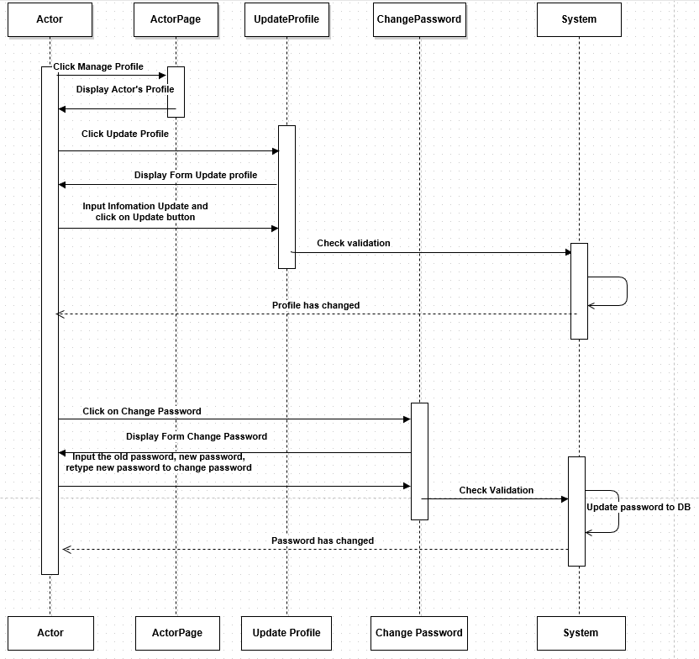

**7.2.3 Logout**

|  |  |  |
| --- | --- | --- |
| **Author** | Nguyen Chi Tan | |
| **Use Case Name** | Logout | |
| **Actors** | Custommer or General public or Worker | |
| **Description** | Custommer or General public or Worker wants to log out of the System. | |
| **Requirements** | Choose OK from confirm dialog | |
| **Pre-conditions** | Actor has logged in. | |
| **Post-conditions** | Success: Actor Logged out. | |
| **Basic flow** | Actor Actions:  1. Actor click ‘Log out’ link on the Actor’s Home menu.  3.Actor click on ‘OK’ on confirm dialog | System Responses:  2. Display a yes/no confirm dialog.  4. System redirect to Logout page, remove session, and then redirect to Login page. |
| **Alternative flow** |  |  |
| **Exception** |  |  |

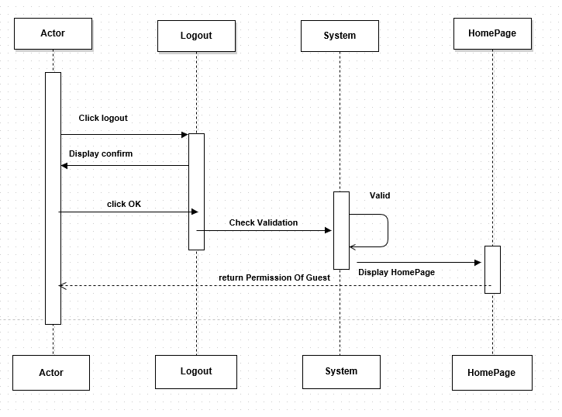

**7.3 General Public and Customer**

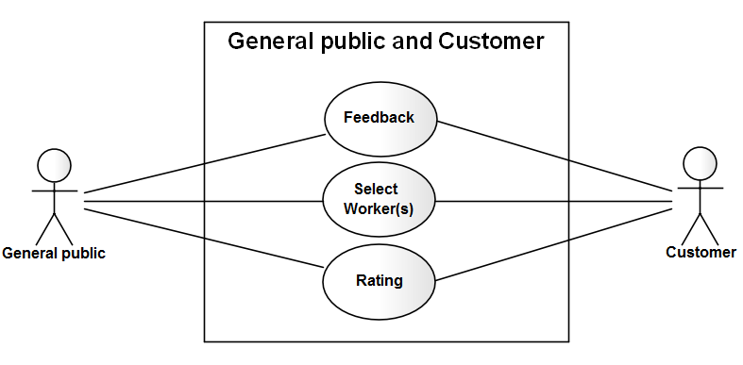

**7.3.1 General Public and Customer’s Feedback**

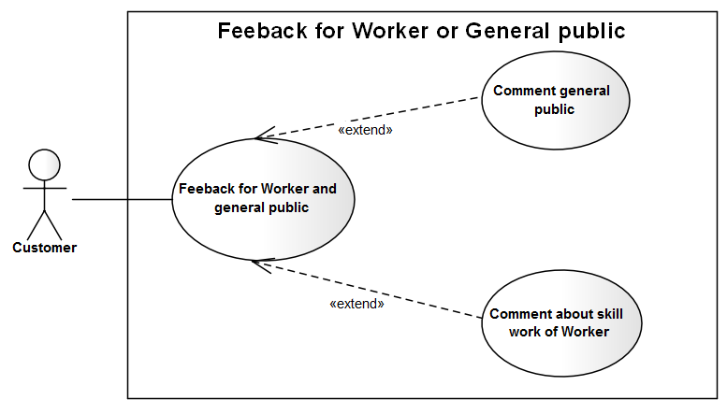

|  |  |  |
| --- | --- | --- |
| **Author** | Trinh Cong Thanh | |
| **Use Case Name** | Feedback | |
| **Actors** | Custommer or General public | |
| **Description** | Custommer or General public feedback | |
| **Requirements** |  | |
| **Pre-conditions** | Actor has logged in. | |
| **Post-conditions** |  | |
| **Basic flow** | Actor Actions:  1. Actor clicks ‘Feedback’ button on the Actor Home page menu.  3. Actor inputs UserName Need feedback, Content Comment, and click ‘Feedback’ button. [Alternative 1] | System Responses:  2. System redirect to FeedbackPage and show Feedback form with the following controls:  - ‘FeedbackTo’ text field.  - ‘Content’text field.  - ‘Feedback’ button.  - ‘Back to Home’ button.  4. System checks the information  [Exception 1].  5. System Insert information Feedback to system. |
| **Alternative flow** | Actor Actions:  [Alternative 1]  1. Actor click ‘Back to Home’ button. | System Responses:  2. System returns to Actor Home page. |
| **Exception** | [Exception 1]  1. UserName is invalid, username is not null  2. Content Comment not null  3. Input Content Comment more than 20 character and less than 500 character | System Responses:  - System shows the message: ‘Invalid Username’,’username is not null’.- System shows the message:’comtent is not null, more than 20 character and less than 500 character’. |

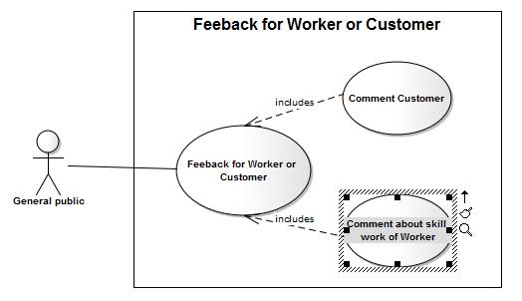

|  |  |  |
| --- | --- | --- |
| **Author** | Hong Lam Son | |
| **Use Case Name** | Feedback | |
| **Actors** | Worker or Customer | |
| **Description** | General public feedback | |
| **Requirements** |  | |
| **Pre-conditions** | Actor has logged in. | |
| **Post-conditions** |  | |
| **Basic flow** | Actor Actions:  1. Actor clicks ‘Feedback’ button on the Actor Home page menu.  3. Actor inputs UserName Need feedback, Content Comment, and click ‘Feedback’ button. [Alternative 1] | System Responses:  2. System redirect to FeedbackPage and show Feedback form with the following controls:  - ‘FeedbackTo’ text field.  - ‘Content’text field.  - ‘Feedback’ button.  - ‘Back to Home’ button.  4. System checks the information  [Exception 1].  5. System Insert information Feedback to system. |
| **Alternative flow** | Actor Actions:  [Alternative 1]  1. Actor click ‘Back to Home’ button. | System Responses:  2. System returns to Actor Home page. |
| **Exception** | [Exception 1]  1. UserName is invalid, username is not null  2. Content Comment not null  3. Input Content Comment more than 20 character and less than 500 character | System Responses:  - System shows the message: ‘Invalid Username’,’username is not null’.- System shows the message:’comtent is not null, more than 20 character and less than 500 character’. |

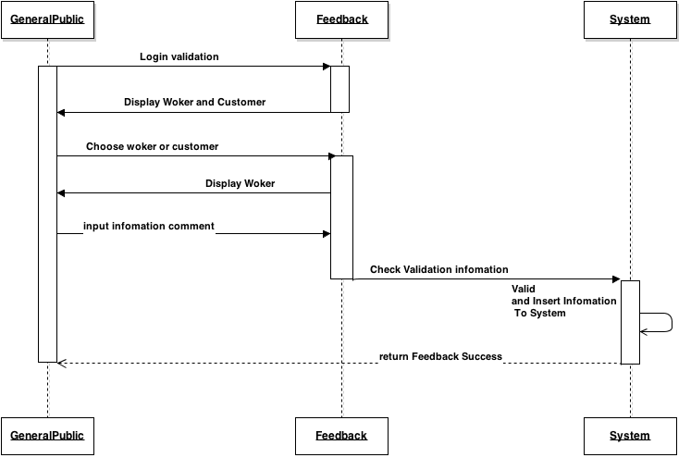

**7.3.2 Ratting**

|  |  |  |
| --- | --- | --- |
| **Author** | Trinh Cong Thanh | |
| **Use Case Name** | Rating Woker | |
| **Actors** | Custommer | |
| **Description** | Custommer or General public ratting worker | |
| **Requirements** |  | |
| **Pre-conditions** | Actor has logged in. | |
| **Post-conditions** |  | |
| **Basic flow** | Actor Actions:  1. Actor clicks ‘select Woker’ button on the Actor Home page menu.  3.Actor Choose worker and click button ratting to group  5.Actor input information ratting and click ‘Submit’ button [Alternative 1] | System Responses:  2. System redirect to Select Worker and show list Woker  4. Form rating worker display with the following controls:  - Worker Skill  - Charges  - Particularity about time,  - dedication  - behavior  - habits  - ‘Submit’ buttom  - ‘Cancel’ button.  6. System checks the information  7. System Update rangting to system. |
| **Alternative flow** | Actor Actions:  [Alternative 1]  1. Actor click ‘Cancel’ button. | System Responses:  2. System returns to Actor Home page. |
| **Exception** |  |  |

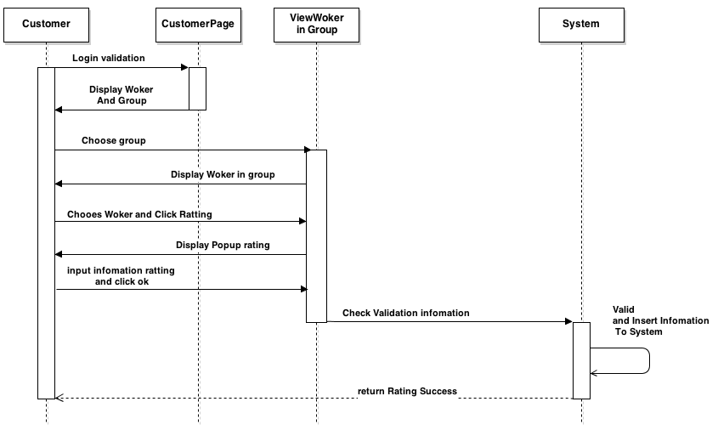

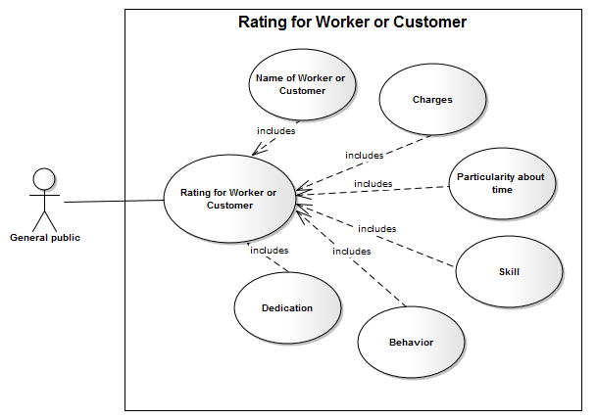

|  |  |  |
| --- | --- | --- |
| **Author** | Hong Lam Son | |
| **Use Case Name** | Rating Woker | |
| **Actors** | General public | |
| **Description** | General public rating worker | |
| **Requirements** |  | |
| **Pre-conditions** | Actor has logged in. | |
| **Post-conditions** |  | |
| **Basic flow** | Actor Actions:  1. Actor clicks ‘select Woker’ button on the Actor Home page menu.  3.Actor Choose worker and click button rating to group  5.Actor input information rating and click ‘Submit’ button [Alternative 1] | System Responses:  2. System redirect to Select Worker and show list Woker  4. Form rating worker display with the following controls:  - Worker Skill  - Charges  - Particularity about time,  - dedication  - behavior  - habits  - ‘Submit’ button  - ‘Cancel’ button.  6. System checks the information  7. System Update rating to system. |
| **Alternative flow** | Actor Actions:  [Alternative 1]  1. Actor click ‘Cancel’ button. | System Responses:  2. System returns to Actor Home page. |
| **Exception** |  |  |

**7.4 Worker**

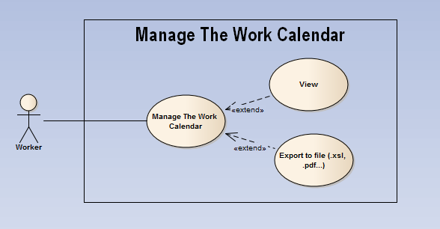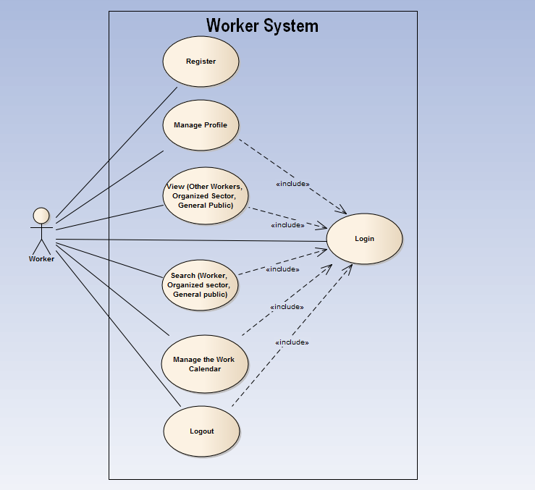 **7.4.1 Manage The Work Calendar**

|  |  |  |
| --- | --- | --- |
| **Author** | Nguyen Chi Tan | |
| **Use Case Name** | Manage The Work Calendar | |
| **Actors** | Worker | |
| **Description** | Worker | |
| **Requirements** |  | |
| **Pre-conditions** | Actor has logged in. | |
| **Post-conditions** | Success: Work calendar has exported to a file | |
| **Basic flow** | Actor Actions:  1. Actor clicks ‘Manage Profile’ link on the Worker Home page.  3.Actor click ‘View Work Calendar’ link on the Manage Worker Profile page.  5.Actor choose the type to export the work calendar file (.pdf or .xls) Then click OK [Alternative 1] | System Responses:  2. System redirect to Manage Worker Profile page.  4. Display Work Calendar to worker  6. System checks the information  7. Export work calendar to a file. |
| **Alternative flow** | Actor Actions:  [Alternative 1]  1. Actor click ‘Cancel’ button. | System Responses:  2. System redirect to Manage worker profile page. |
| **Exception** |  |  |

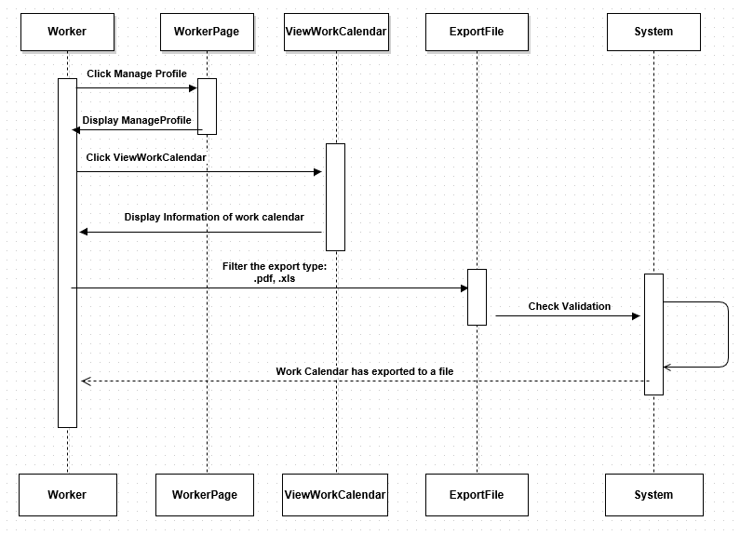

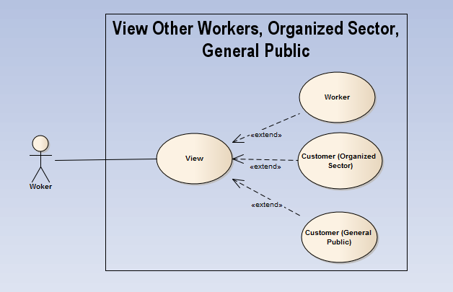 **7.4.2 View Other Workers, Organized Sector, General Public**

|  |  |  |
| --- | --- | --- |
| **Author** | Nguyen Chi Tan | |
| **Use Case Name** | View | |
| **Actors** | Worker | |
| **Description** | View Other Workers, Organized Sector, General Public | |
| **Requirements** | Click on Worker or Organized Sector or  General Public to choose the specific view | |
| **Pre-conditions** | Actor has logged in. | |
| **Post-conditions** |  | |
| **Basic flow** | Actor Actions:  1. Actor clicks on Worker or Organized Sector or General Public to choose the specific view. | System Responses:  2. System notify to worker about each finished task.  3. System checks the view condition.  4. Information about each finished task. |
| **Alternative flow** |  |  |
| **Exception** |  |  |

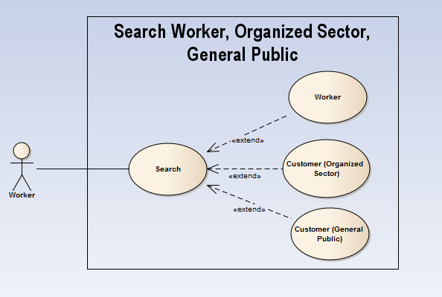 **7.4.3 Search Other Workers, Organized Sector, General Public** 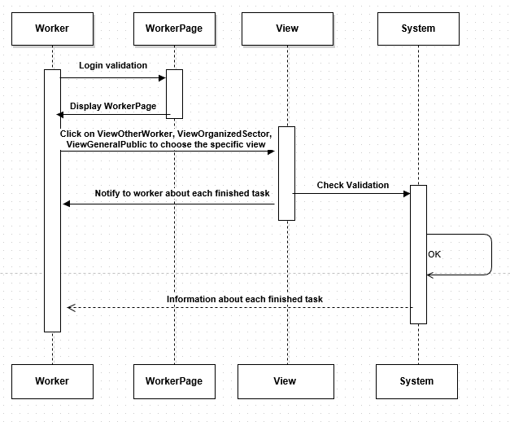

|  |  |  |
| --- | --- | --- |
| **Author** | Nguyen Chi Tan | |
| **Use Case Name** | Search | |
| **Actors** | Worker | |
| **Description** | Search Other Workers, Organized Sector, General Public | |
| **Requirements** | Input the name of worker, organized sector,  general public to search. | |
| **Pre-conditions** | Actor has logged in. | |
| **Post-conditions** | Success: View Searching information  Fail: ReEnter the name | |
| **Basic flow** | Actor Actions:   1. Actor Input the name of worker, organized sector, general public to search. 2. Click on Search button | System Responses:  3. System checks validation  [Exception 1]  4. Information about each finished task. |
| **Alternative flow** |  |  |
| **Exception** | [Exception 1]  Actor lefts ‘FirstName’ text field blank | System Responses:  - ‘Name’ cannot left blank |

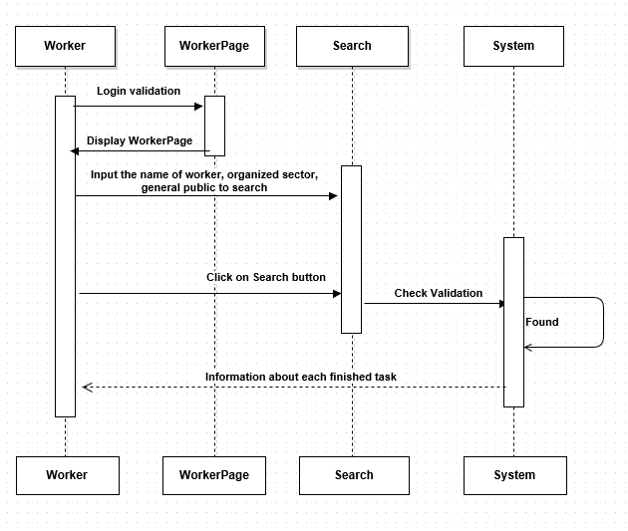

**7.5 Customer**

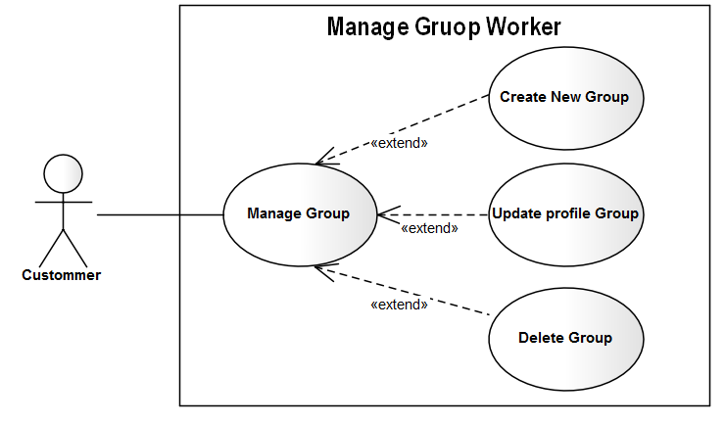 **7.5.1 Manage The Group Of Worker**

|  |  |  |
| --- | --- | --- |
| **Author** | Trinh Cong Thanh | |
| **Use Case Name** | Manage Group Woker | |
| **Actors** | Custommer | |
| **Description** | Custommer | |
| **Requirements** |  | |
| **Pre-conditions** | Actor has logged in. | |
| **Post-conditions** |  | |
| **Basic flow** | Actor Actions:  1. Actor clicks ‘manage Group’ button on the Actor Home page menu.  3. Actor clicks ‘Create Group’ button on the Actor Home page menu  6. ActorInput information and click ‘Create Group’ button [Alternative 1]  7. Actor choose Group and click edit on Actor homepage  9. Actor input information and click ‘Update’ button [Alternative 1]  11. Actor choose Group and click Delete on Actor homepage  13.Action click ‘Delete’ botton [Alternative 1] | System Responses:  2.System redirect to GroupWorker Page and showlist Group of worker  4. Form Create new Group Display with the following controls  - ‘Group Name’ text field.  - ‘Descripttion’text field.  - ‘Create Group’ button.  - ‘Cancel’ button.  6. System Insert information to system  8. Form Update Group Display with the following controls :  ‘Group Name’ text field.  - ‘Descripttion’text field.  - ‘Update’button.  - ‘Cancel’ button.  10. System Update information to system  12. Cofirm popup delete group display  - ‘Delete’ button  -‘Cancel’ button  [Exception 1].  14. System Delete information to system. |
| **Alternative flow** | Actor Actions:  [Alternative 1]  1. Actor click ‘Cancel’ button. | System Responses:  2. System returns to Actor Home page. |
| **Exception** | [Exception 1]  1. Group name is not null,Descripttion is not null  2. Input GroupName more than 1 character and less than 250 character  3. Input Descripttion more than 10 character and less than 250 character | System Responses:  - System shows the message: ‘Group name’,’ Descripttion” is not null.  - System shows the message: GroupName more than 1 character and less than 250 character’.  - System shows the message: Descripttion more than 10 character and less than 250 character’ |

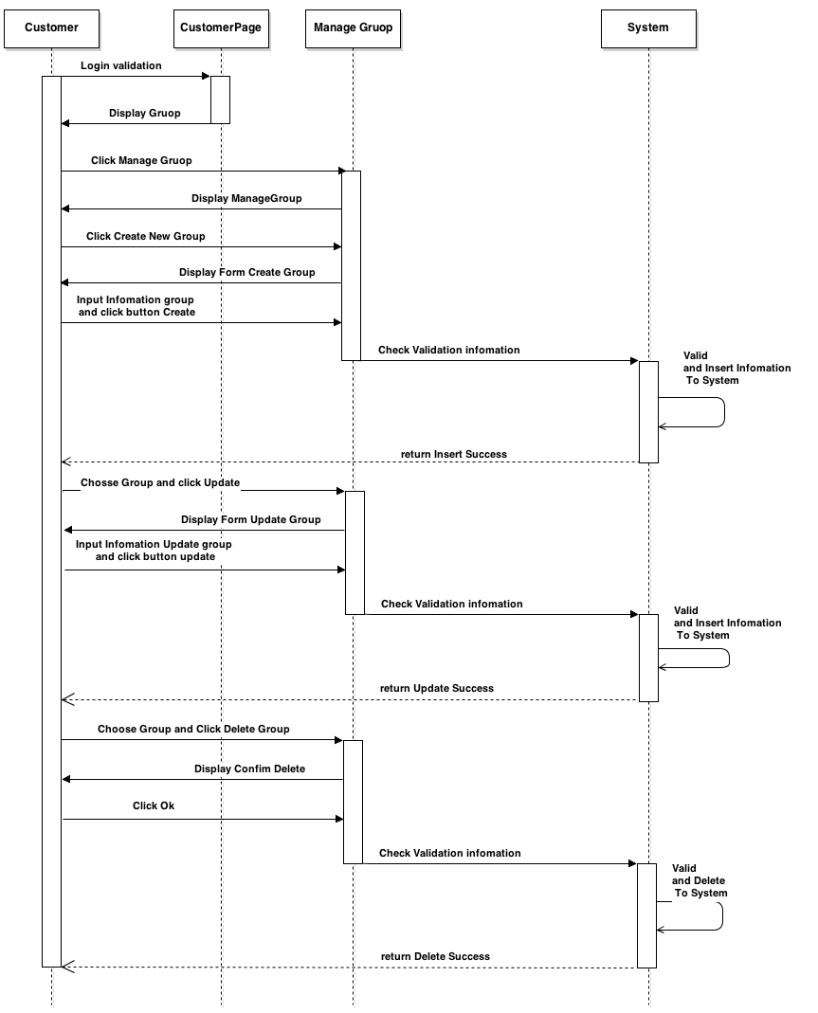

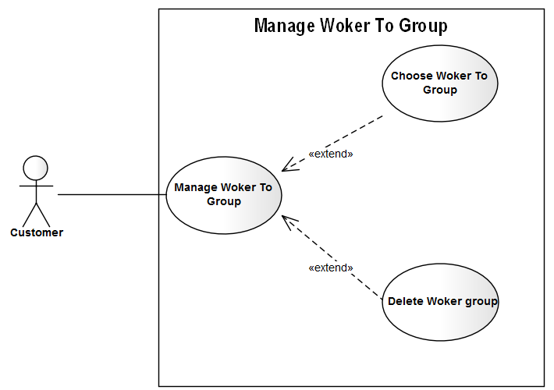 **7.5.2 Manage Worker To Group**

|  |  |  |
| --- | --- | --- |
| **Author** | Trinh Cong Thanh | |
| **Use Case Name** | Manage Woker in Group | |
| **Actors** | Custommer | |
| **Description** | Custommer | |
| **Requirements** |  | |
| **Pre-conditions** | Actor has logged in. | |
| **Post-conditions** |  | |
| **Basic flow** | Actor Actions:  1. Actor clicks ‘manage Worker in group” button on the Actor Home page menu.  3 Actor choose Woker click button add to group on the table list Woker  5 . Actor Click ok [Alternative 1]  7. Actor view Group  9.Choose Worker in group and click ‘Delete’ button  11. Click ‘submit’ button  [Alternative 1] | System Responses:  2.System redirect to Worker to groupPage and showlist Worker to group  4. Confirm Add Woker is choose on group popup Show with  - ‘Submit’ button  - ‘Cancel’ button  6. System Insert information to system  8.System redirect to showlist Worker in group  10. popup Confirm Delete Worker in group with  -‘Submit’ button.  -‘Cancel’ button.  [Exception 1].  12. System Delete information to system. |
| **Alternative flow** | Actor Actions:  [Alternative 1]  1. Actor click ‘Cencel’ button. | System Responses:  2. System returns to Actor Home page. |
| **Exception** |  |  |

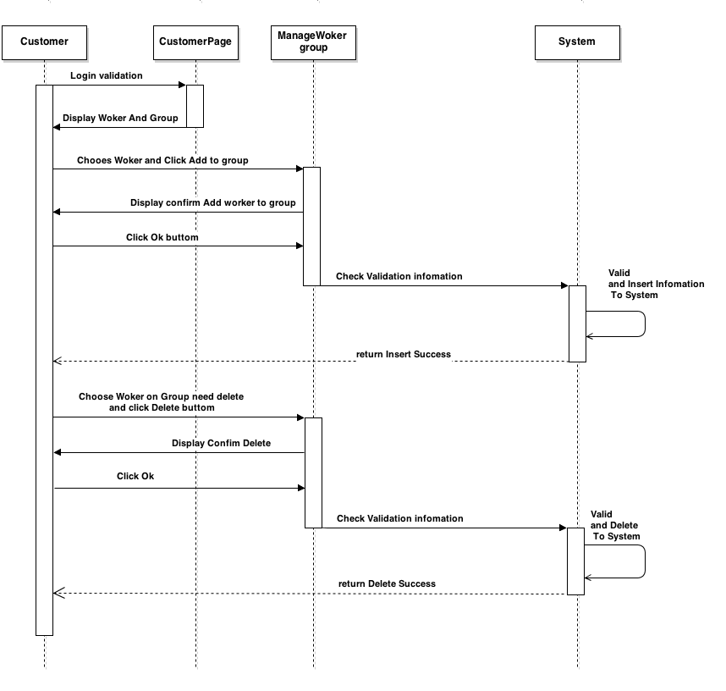

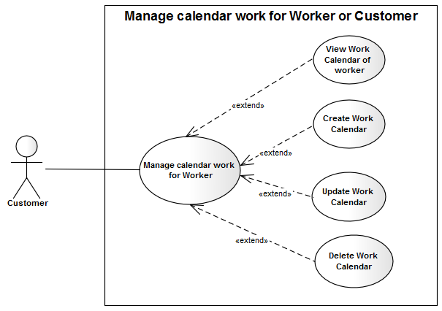**7.5.3 Manage Work Calendar**

|  |  |  |
| --- | --- | --- |
| **Author** | Trinh Cong Thanh | |
| **Use Case Name** | Manage Work Calendar | |
| **Actors** | Custommer | |
| **Description** | Custommer | |
| **Requirements** |  | |
| **Pre-conditions** | Actor has logged in. | |
| **Post-conditions** |  | |
| **Basic flow** | Actor Actions:  1. Actor clicks ‘manage Work Calendar  3 .Actor choose Woker click ‘View Work calendar’p on the table list Woker  5. Actor click ‘Close’ button  6 . Actor choose woker and click ‘create Work calendar’ button  8. Actor Click Submit [Alternative 1]  10.Actor choose woker and click ‘Update Work calendar’ button  12. Actor Click Submit [Alternative 1]  14.Choose Worker in group and click ‘Delete Calendar’ button  16. Actor Click Submit [Alternative 1] | System Responses:  2.System showlist Worker on group  3.System Show information Work calendar of worker with  - ‘Close’ button  5. System Close view Work calendar  7. Form Create Work Calendar Show with  - droplist From Time All Of Week  - droplist To Time All Of Week  - ‘Submit’ button  - ‘Cancel’ button  [Exception 1].  9. System Insert information to system  11. Form Create Work Calendar Show with  -‘StartDate’ text field  -‘EndDate’ text field  - droplist Srart Time All Of Week  - droplist End Time All Of Week  - ‘Submit’ button  - ‘Cancel’ button  [Exception 1].  13. System Update information to system  15. pupup Confirm delete Show With  - ‘Submit’ button  - ‘Cancel’ button  13. System Delete information to system |
| **Alternative flow** | Actor Actions:  [Alternative 1]  1. Actor click ‘Back to Home’ button. | System Responses:  2. System returns to Actor Home page. |
| **Exception** | [Exception 1].  1.‘StartDate’ text field is not null  2.‘EndDate’ text field is not null  3.StartDate more less than EndDate  4.Start Time All Of Week more less than End Time All Of Week | [Exception 1].  1.System shows the message : Stardate not null  1.System shows the message : Enddate not null  3.System shows the message : StartDate more less than EndDate  4.Start Time All Of Week more less than End Time All Of Week |

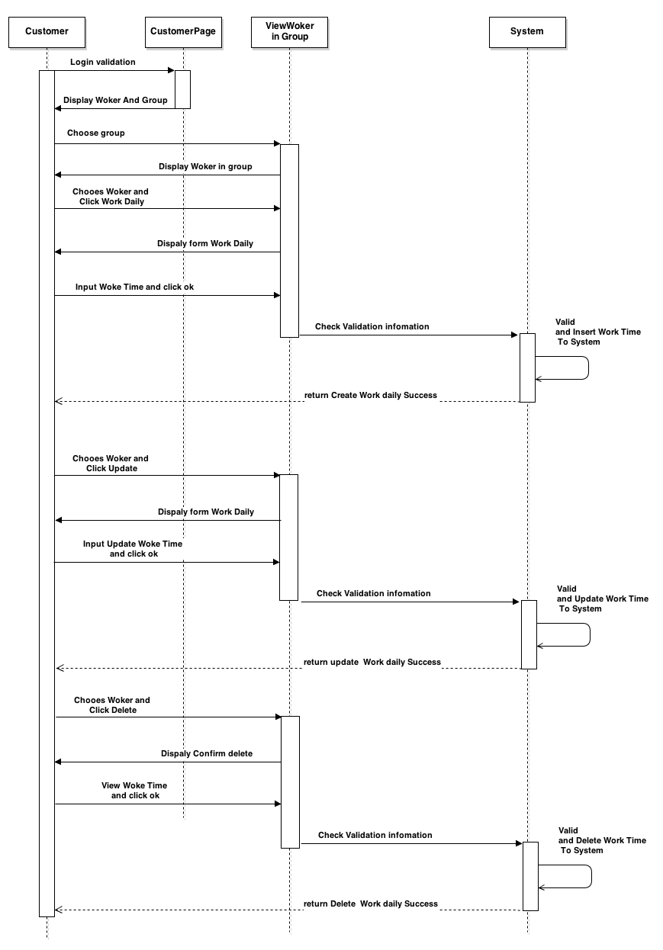

**7.6 General Public**

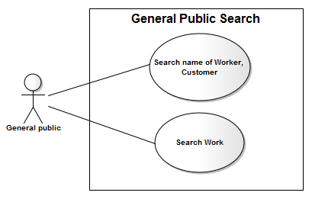 **7.6.1 Search General Public**

|  |  |  |
| --- | --- | --- |
| **Author** | Hong Lam Son | |
| **Use Case Name** | General public Search | |
| **Actors** | General public | |
| **Description** | General public wants to search a name of Worker or search a Working. | |
| **Requirements** | Actor provides search information | |
| **Pre-conditions** | Actor has logged in as General public | |
| **Post-conditions** | Success: Properties match the condition show up.  Fail: Do not have any property match the condition. | |
| **Basic flow** | Actor Actions:  1. Actor clicks ‘Search button on the Actor’s Home menu.  2. Actor input information va click ‘Search’ button [Alternative 1] | System Responses:  2. System show the Search contains the following category:  - ‘Search’ text field  - ‘Category’ combobox  - ‘Search’ button  3.System view information on table result Search |
| **Alternative flow** | Actor Actions:  [Alternative 1]  1. Actor click ‘Back to Home’ button. | System Responses:  2. System returns to Actor Home page. |
| **Exception** | Actor Actions:  [Exception 1]  1. Actor lefts ‘Search’ text field blank. | System Response:  System displays message to Actor :  - ‘Information search cannot be blank’. |

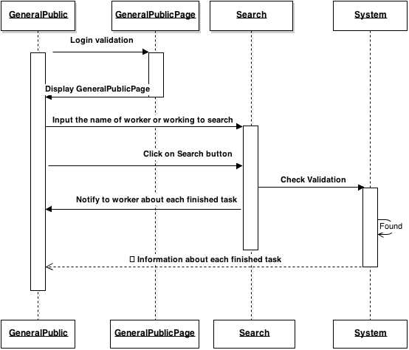

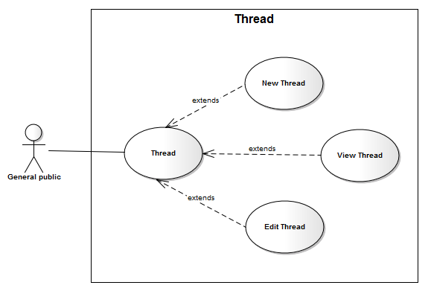 **7.6.2 Manage Thread**

|  |  |  |
| --- | --- | --- |
| **Author** | Hong Lam Son | |
| **Use Case Name** | Thread | |
| **Actors** | General Public | |
| **Description** | General Public want to submit a new thread, view thread and edit thread | |
| **Requirements** | Actor provides information work and time work | |
| **Pre-conditions** | Actor has logged in as general public | |
| **Post-conditions** | Success: Entry information will be inserted into the database  Fail: Refill information | |
| **Basic flow** | Actor Actions:  1. Actor clicks Thread button on General public menu.  3. Actor choose threads and click ‘Edit’ button  5. Actor input information and click ‘Save’ button. [Alternative 1]  7. Actor chooses New thread.  8. Actor input information and click ‘Submit’ button. [Alternative 1] | System Response:  2. System displays ‘Thread’ page  4. System displays form for Actor to input information with the following control:  - Button ‘Browse’ to upload image  - ‘workAddress’ text field  - ‘workAddress’ text field  - ‘workCity’ text field  - ‘workState’ text field  - ‘workLoc’ text field  - ‘startDate’ combobox  - ‘endDate’ combobox  - ‘startTime text field  - ‘endTime’ text field  - ‘workDetails’ text area  - ‘chargesHrs’ text field  - ‘chargesDaily’ text field  - ‘Save’ button  - ‘Cancel’ button  - ‘Back to Home’ button  6. System Update information to system  8. System displays form for Actor to input information with the following control:  - Button ‘Browse’ to upload image  - ‘workAddress’ text field  - ‘workCountry’ text field  - ‘workCity’ text field  - ‘workLoc’ text field  - ‘startDate’ combobox  - ‘endDate’ combobox  - ‘startTime text field  - ‘endTime’ text field  - ‘workDetails’ text area  - ‘chargesHrs’ text field  - ‘chargesDaily’ text field  - ‘Submit’ button  - ‘Cancel’ button  - ‘Back to Home’ button  9. System Insert information to system |
| **Alternative flow** | Actor Actions:  [Alternative 1]  1. Actor click ‘Back to Home’ button. | System Response:  2. System returns to Home page. |
| **Exceptions** | Actor Actions:  [Exception 1]  1. Actor lefts ‘workAddress’ text field blank.  2. Actor lefts ‘workCountry’ text field blank.  3. Actor lefts ‘workCity’ text field blank.  4. Input ‘workLoc’ required to 5 – 250 characters  5. Actor lefts ‘startDate’ combobox blank.  6. Actor lefts ‘endDate’ combobox blank.  7. Input ‘endDate’ more than ‘startDate’  7. Actor lefts ‘startTime’ text field blank.  8. Actor lefts ‘endTime’ text field blank.  9. Actor lefts ‘workDetails’ text area blank.  10. Input ‘workDetails’ required to 5 – 50 characters.  11. Actor lefts ‘chargesHrs’ text area blank.  12. Check input ‘chargesHrs’ is Degit and more than zero .  13. Actor lefts ‘chargesDaily’ text area blank.  14. Check input ‘chargesDaily’ is Degit and more than zero . | System Response:  System displays message to Actor :  - ‘Working Address cannot be blank’.  - ‘Working Country cannot be blank’.  - ‘Working City cannot be blank’.  - ‘Working Locale’ must be between 5 and 250 characters.  - ‘Start Date cannot be blank’.  - ‘End Date cannot be blank’.  - ‘End Date’ must be more than ‘Start Date’.  - ‘Start Time cannot be blank’.  - ‘End Time cannot be blank’.  - ‘Working detail cannot be blank’.  - ‘Working detail’ must be between 5 and 50 characters.  - ‘Charges Hours cannot be blank’.  - ‘Charges Hours’ should be degit and more than zero.  - ‘Charges Daily cannot be blank’.  - ‘Charges Daily’ should be degit and more than zero. |

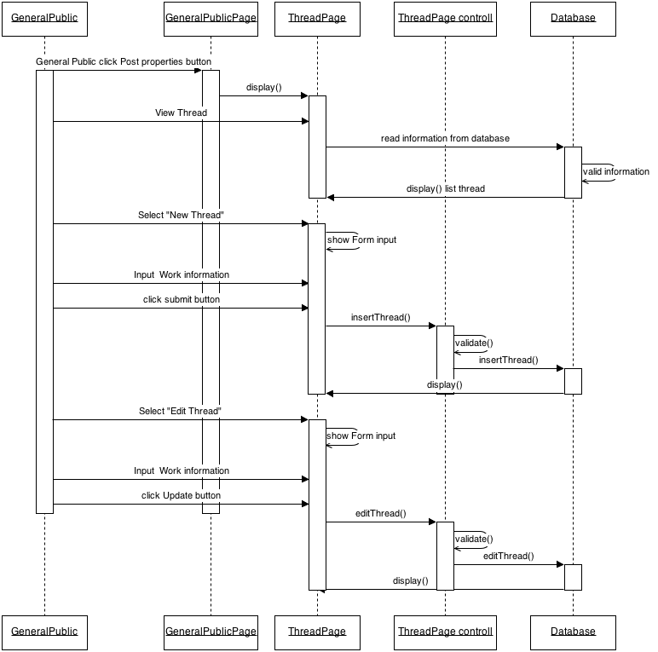

**7.7 Administrator**

**7.7.1 Manage Topic**

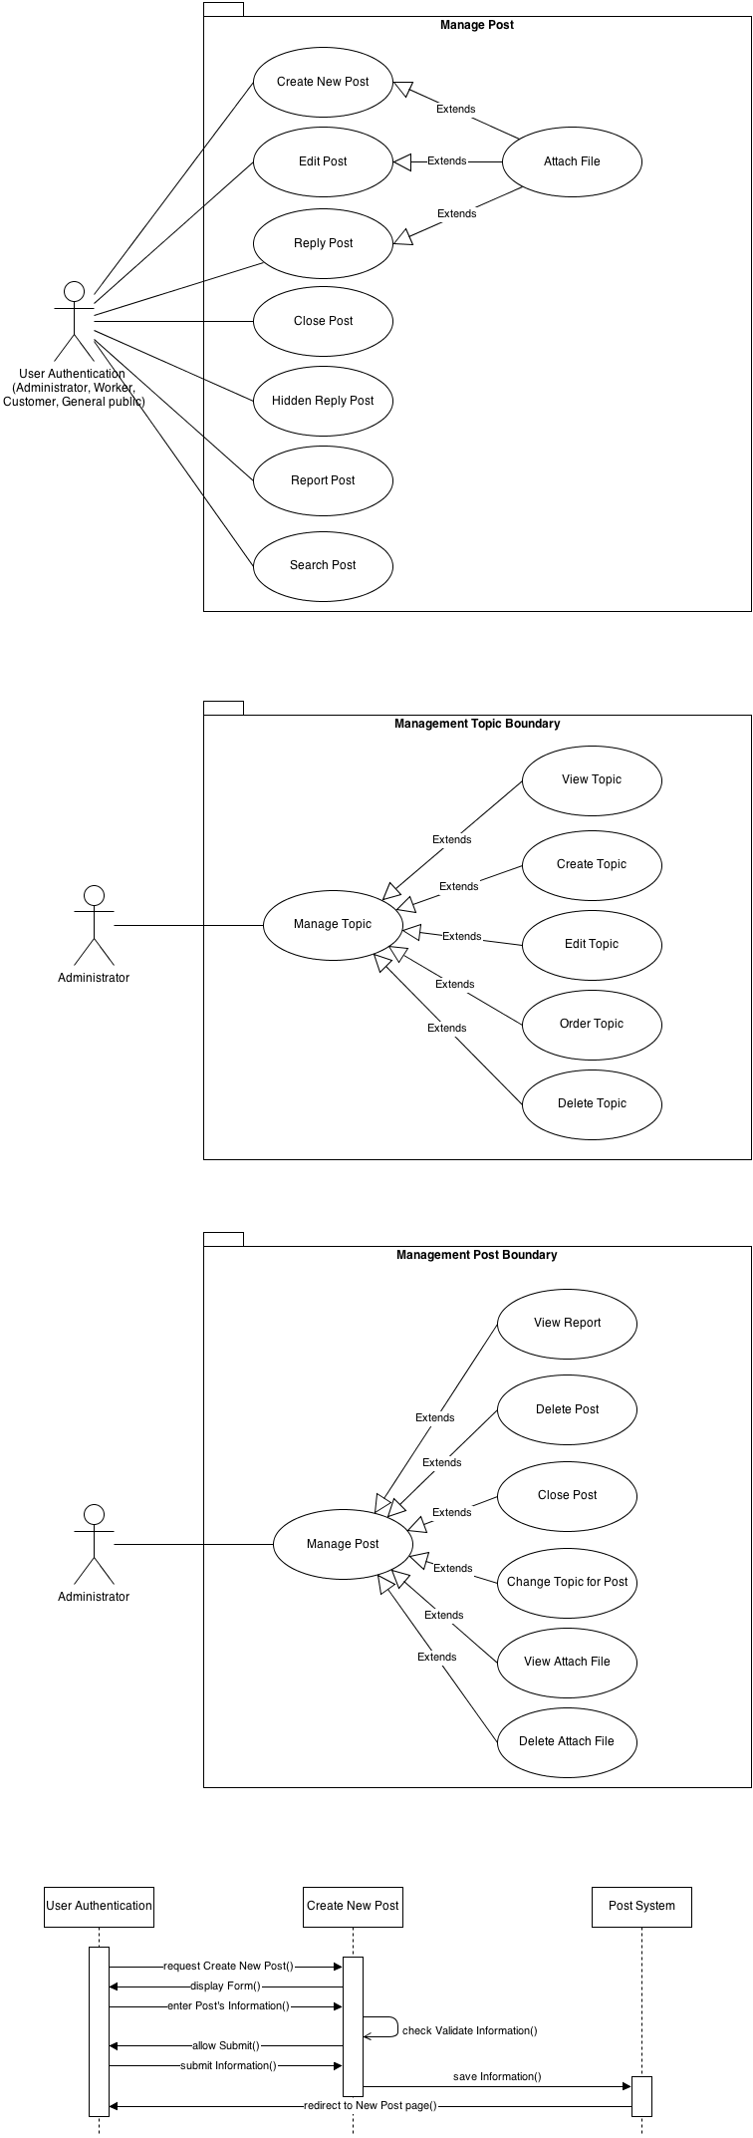 **7.7.1.1 View Topic**

|  |  |  |
| --- | --- | --- |
| **Author** | Phan Trong Nhan. | |
| **Use Case Name** | View Topic. | |
| **Actors** | Administrator. | |
| **Description** | Administrator can view list topic. | |
| **Requirements** |  | |
| **Pre-conditions** | Actor has logged in System. | |
| **Post-conditions** |  | |
| **Basic flow** | Actor Actions:  1. Actor clicks to Manage Topic link. | System Responses:  2. Display grid topic ordered. |
| **Alternative flow** |  |  |
| **Exception** |  |  |

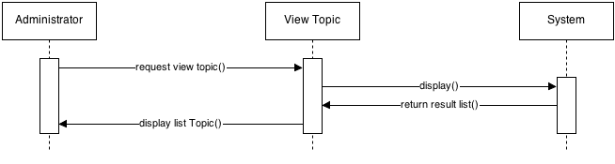

**7.7.1.2 Create Topic**

|  |  |  |
| --- | --- | --- |
| **Author** | Phan Trong Nhan. | |
| **Use Case Name** | Create Topic. | |
| **Actors** | Administrator. | |
| **Description** | Administrator can create new topic. | |
| **Requirements** | Administrator provides Post’s information (Name, position). | |
| **Pre-conditions** | Actor has logged in System. | |
| **Post-conditions** | Success: Create new topic, redirect to this View topic page.  Fail: Refill information. | |
| **Basic flow** | Actor Actions:  1. Actor selects topic parent.  3. Actor clicks Add in this topic.  5. Actor inputs name for this topic and clicks ‘Save’ button. [Alternative 1] | System Responses:  2. Display list child topic.  4. Display form Add New Topic has a textfield is ‘Name’.  6. Check information. [Exception 1]  7. Save topic to database and redirect to this page. |
| **Alternative flow** | Actor Actions:  [Alternative 1]  1. Actor click ‘Cancel’ button. | System Responses:  2. System close form Create. |
| **Exception** | Actor Actions:  [Exception 1]  1. Actor leaves ‘Title’ text field blank.  2. Actor input text with length beyond 250 character. | System Responses:  System displays message to Actor :  - ‘Please enter name for topic’.  - ‘This Name so long. Please re-enter name.’. |

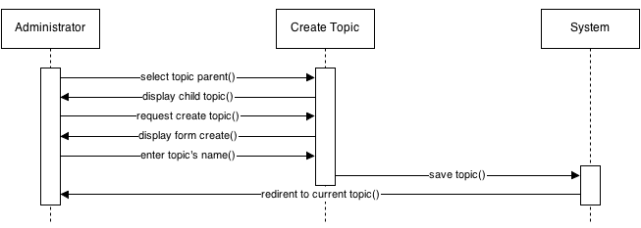

**7.7.1.3 Edit Topic**

|  |  |  |
| --- | --- | --- |
| **Author** | Phan Trong Nhan. | |
| **Use Case Name** | Edit Topic. | |
| **Actors** | Administrator. | |
| **Description** | Administrator can edit topic. | |
| **Requirements** | Administrator provides Post’s name. | |
| **Pre-conditions** | Actor has logged in System. | |
| **Post-conditions** | Success: Update topic, redirect to this View topic page.  Fail: Refill information. | |
| **Basic flow** | Actor Actions:  1. Actor selects topic.  3. Actor clicks Edit in this topic.  5. Actor inputs name for this topic and clicks ‘Save’ button. [Alternative 1] | System Responses:  2. Display name topic.  4. Display form Edit Topic has a textfield is ‘Name’.  6. Check information. [Exception 1]  7. Save topic to database and redirect to this page. |
| **Alternative flow** | Actor Actions:  [Alternative 1]  1. Actor click ‘Cancel’ button. | System Responses:  2. System close form Edit. |
| **Exception** | Actor Actions:  [Exception 1]  1. Actor leaves ‘Title’ text field blank.  2. Actor input text with length beyond 250 character. | System Responses:  System displays message to Actor :  - ‘Please enter name for topic’.  - ‘This Name so long. Please re-enter name.’. |

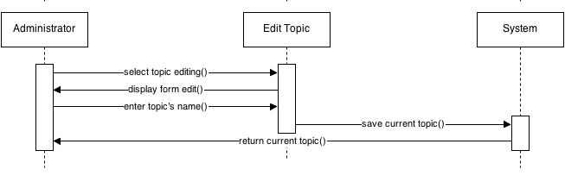

**7.7.1.4 Order Topic**

|  |  |  |
| --- | --- | --- |
| **Author** | Phan Trong Nhan. | |
| **Use Case Name** | Order Topic. | |
| **Actors** | Administrator. | |
| **Description** | Administrator can order topic. | |
| **Requirements** |  | |
| **Pre-conditions** | Actor has logged in System. | |
| **Post-conditions** | Success: Update topic, redirect to this View topic page. | |
| **Basic flow** | Actor Actions:  1. Actor selects topic.  3. Actor drag and drop topic to positon difference.  5. Actor clicks ‘Save’ button. [Alternative 1] | System Responses:  2. Display name topic.  4. Display grid Topic ordered.  6. Save topic to database and redirect to this page. |
| **Alternative flow** | Actor Actions:  [Alternative 1]  1. Actor click ‘Cancel’ button. | System Responses:  2. System return position old of this topic. |
| **Exception** |  |  |

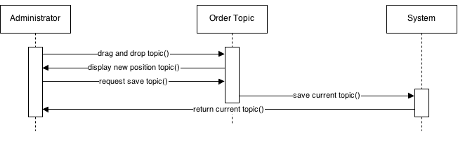

**7.7.1.5 Delete Topic**

|  |  |  |
| --- | --- | --- |
| **Author** | Phan Trong Nhan. | |
| **Use Case Name** | Delete Topic. | |
| **Actors** | Administrator. | |
| **Description** | Administrator can delete topic. | |
| **Requirements** | Administrator choice a topic. | |
| **Pre-conditions** | Actor has logged in System. | |
| **Post-conditions** | Success: Delete topic, redirect to this View topic page. | |
| **Basic flow** | Actor Actions:  1. Actor selects topic.  3. Actor clicks Delete button.  5. Actor clicks ‘Yes’ button. [Alternative 1] | System Responses:  2. Display content topic.  4. Display confirm dialog with text ‘Are you sure to delete this topic’.  6. Delete topic in database and redirect to this page. |
| **Alternative flow** | Actor Actions:  [Alternative 1]  1. Actor click ‘Cancel’ button. | System Responses:  2. System close dialog confirm. |
| **Exception** |  |  |

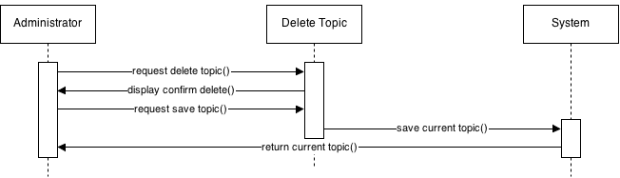

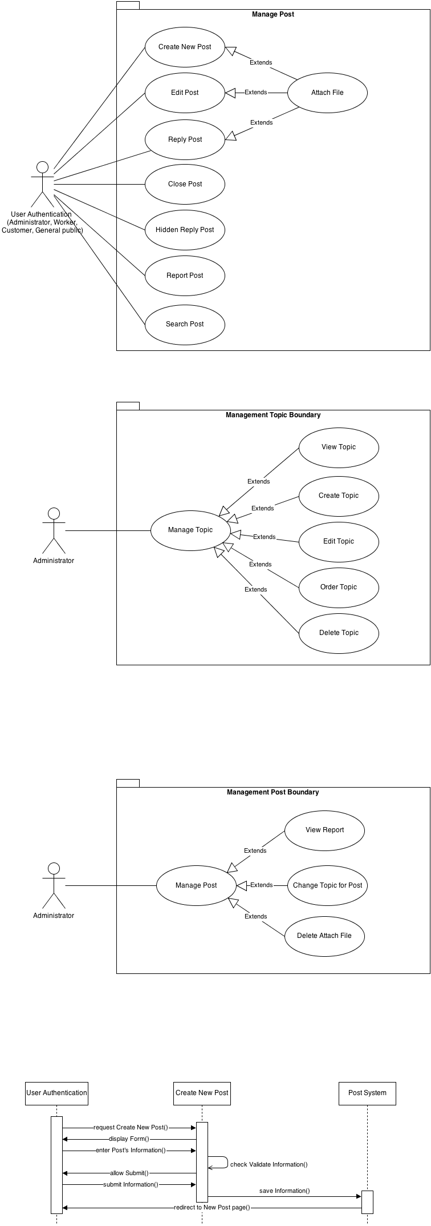**7.7.2Manage Post**

**7.7.2.1 View Report**

|  |  |  |
| --- | --- | --- |
| **Author** | Phan Trong Nhan. | |
| **Use Case Name** | View Report. | |
| **Actors** | Administrator. | |
| **Description** | Administrator can view report. | |
| **Requirements** |  | |
| **Pre-conditions** | Actor has logged in System. | |
| **Post-conditions** |  | |
| **Basic flow** | Actor Actions:  1. Actor clicks on View Report in Post page.  3. Actor clicks on Report link. | System Responses:  2. Display list report of user.  4. Redirect to this post. |
| **Alternative flow** |  |  |
| **Exception** |  |  |

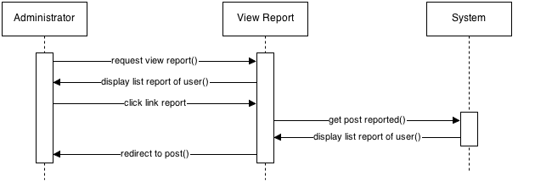

**7.7.2.2 Change Topic For Post**

|  |  |  |
| --- | --- | --- |
| **Author** | Phan Trong Nhan. | |
| **Use Case Name** | Change Topic For Post. | |
| **Actors** | Administrator. | |
| **Description** | Administrator can change topic for post. | |
| **Requirements** | Administrator provides topic target. | |
| **Pre-conditions** | Actor has logged in System. | |
| **Post-conditions** | Success: Update post, redirect to this View post page. | |
| **Basic flow** | Actor Actions:  1. Actor selects post.  3. Actor selects topic target and click ‘Save’ button. [Alternative 1] | System Responses:  2. Display content post.  4. Save post to database and redirect to this page. |
| **Alternative flow** | Actor Actions:  [Alternative 1]  1. Actor click ‘Cancel’ button. | System Responses:  2. System redirect to View List Post page. |
| **Exception** |  |  |

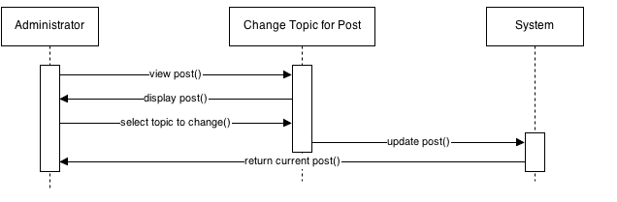

**7.7.3.3 Delete Attach File**

|  |  |  |
| --- | --- | --- |
| **Author** | Phan Trong Nhan. | |
| **Use Case Name** | Delete Attach File. | |
| **Actors** | Administrator. | |
| **Description** | Administrator can delete attach file. | |
| **Requirements** | Administrator select file had content disprove regulative. | |
| **Pre-conditions** | Actor has logged in System. | |
| **Post-conditions** | Success: Delete file in Syste, delete post attach file, redirect to this page. | |
| **Basic flow** | Actor Actions:  1. Actor views post.  3. Actor clicks on ‘Delete’ button on this file.  5. Actor clicks ‘Yes’ button. [Alternative 1] | System Responses:  2. Display file attach.  4. Display confirm dialog with text ‘Are you sure to delete this file’.  6. Delete file in system.  7. Delete Attach file in database and redirect to this page. |
| **Alternative flow** | Actor Actions:  [Alternative 1]  1. Actor click ‘Cancel’ button. | System Responses:  2. System close dialog. |
| **Exception** |  |  |

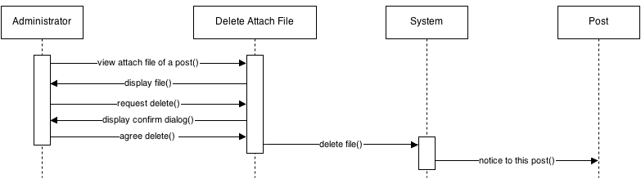

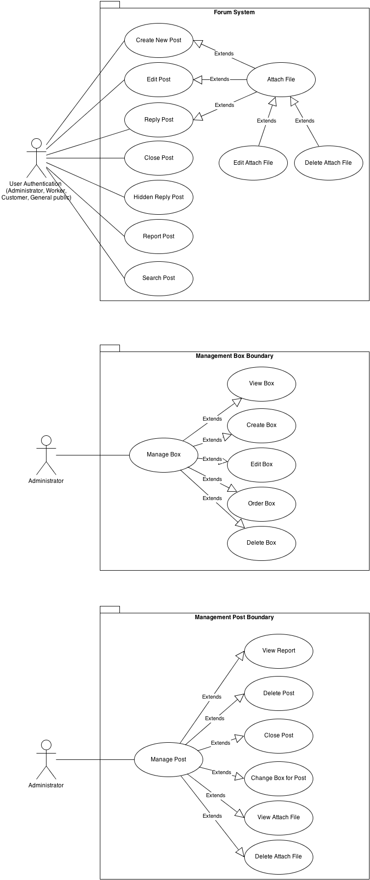**7.8 User Authentication (Administrator, Worker, Customer, General public)**

**7.8.1 Create New Post**

|  |  |  |
| --- | --- | --- |
| **Author** | Phan Trong Nhan. | |
| **Use Case Name** | Create New Post. | |
| **Actors** | User Authentication (Administrator, Worker, Customer, General public). | |
| **Description** | User Authentication who logged in website can create a post in a box topic. | |
| **Requirements** | User provides Post’s information (Title, Content,…). | |
| **Pre-conditions** | Actor has logged in System. | |
| **Post-conditions** | Success: User create a post in system, redirect to this Post.  Fail: Refill information. | |
| **Basic flow** | Actor Actions:  1. Actor choices and clicks topic link.  3. Actor clicks on Create New Post button.  5. Actor inputs post’s information and click ‘Save’ button. [Alternative 1] | System Responses:  2. System redirects to Topic page.  4. System redirects to Create Post page and display Create Post form with the following control:  - ‘Title’ text field  - ‘Content’ text field  - ‘Attach File’ file field  - ‘Captcha’ textbox  - ‘Refresh image’ button  - ‘Save’ button  - ‘Cancel’ button  6. System checks the information  [Exception 1]  7. System inserts the post into database, show message: ‘Your post has been created!’ and then redirects to this Post. |
| **Alternative flow** | Actor Actions:  [Alternative 1]  1. Actor click ‘Cancel’ button. | System Responses:  2. System returns to previous page. |
| **Exception** | Actor Actions:  [Exception 1]  1. Actor leaves ‘Title’ text field blank.  2. Actor input text with length beyond 250 character.  3. Actor leaves ‘Content’ text field blank.  4. Actor choices a file unmatch file types format.  5. Actor uploads file that is beyond 2 MB.  6. Actor leaves ‘Captcha’ text field blank or input an unmatch value. | System Responses:  System displays message to Actor :  - ‘Title cannot be blank’.  - ‘Your title so long. Please enter title less than 250 character.’  - ‘Content cannot be blank’’.  - ‘Your file types is jpg png jpge gif rar zip.  - ‘Files must be less than 2 MB’.  - ‘Not match the image’. |

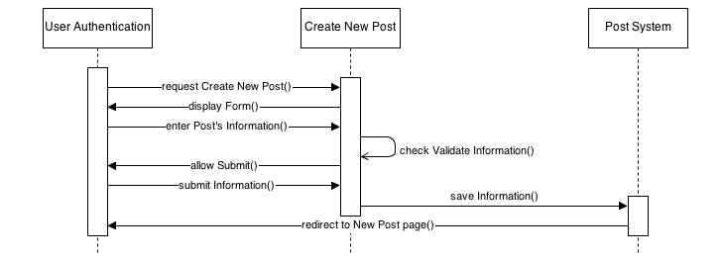

**7.8.2 Edit Post**

|  |  |  |
| --- | --- | --- |
| **Author** | Phan Trong Nhan. | |
| **Use Case Name** | Edit Post. | |
| **Actors** | User Authentication (Administrator, Worker, Customer, General public). | |
| **Description** | User Authentication who logged in website can edit user’s post. | |
| **Requirements** | User provides Post’s information (Title, Content,…). | |
| **Pre-conditions** | Actor has logged in System.  Actor has had post to edit. | |
| **Post-conditions** | Success: User update their own post, redirect to this Post.  Fail: Refill information. | |
| **Basic flow** | Actor Actions:  1. Actor choices and clicks post link.  3. Actor clicks on Edit Post button.  5. Actor inputs post’s information and click ‘Save’ button. [Alternative 1] | System Responses:  2. System redirects to Post page.  4. System redirects to Edit Post page and display Edit Post form with the following control:  - ‘Title’ text field  - ‘Content’ text field  - ‘Attach File’ file field  - ‘Save’ button  - ‘Cancel’ button  6. System checks the information  [Exception 1]  7. System update the post into database, show message: ‘Your post has been updated!’ and then redirects to this Post. |
| **Alternative flow** | Actor Actions:  [Alternative 1]  1. Actor click ‘Cancel’ button. | System Responses:  2. System returns to previous page with data old. |
| **Exception** | Actor Actions:  [Exception 1]  1. Actor leaves ‘Title’ text field blank.  2. Actor input text with length beyond 250 character.  3. Actor leaves ‘Content’ text field blank.  4. Actor choices a file unmatch file types format.  5. Actor uploads file that is beyond 2 MB. | System Responses:  System displays message to Actor :  - ‘Title cannot be blank’.  - ‘Your title so long. Please enter title less than 250 character.’  - ‘Content cannot be blank’’.  - ‘Your file types is jpg png jpge gif rar zip.  - ‘Files must be less than 2 MB’. |

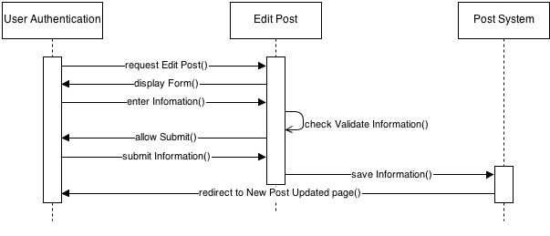

**7.8.3 Reply Post**

|  |  |  |
| --- | --- | --- |
| **Author** | Phan Trong Nhan. | |
| **Use Case Name** | Reply Post. | |
| **Actors** | User Authentication (Administrator, Worker, Customer, General public). | |
| **Description** | User Authentication who logged in website can reply a post. | |
| **Requirements** | User provides Post’s information (Title, Content,…). | |
| **Pre-conditions** | Actor has logged in System. | |
| **Post-conditions** | Success: User Reply a post in system, redirect to this Post.  Fail: Refill information. | |
| **Basic flow** | Actor Actions:  1. Actor choices and clicks post link.  3. Actor clicks on Reply Post button.  5. Actor inputs information reply and click ‘Save’ button. [Alternative 1] | System Responses:  2. System redirects to Post page.  4. System display to Reply Post form with the following control:  - ‘Title’ text field  - ‘Content’ text field  - ‘Attach File’ file field  - ‘Save’ button  - ‘Cancel’ button  6. System checks the information  [Exception 1]  7. System inserts the post into database, show message: ‘Your reply post has been created!’ and then redirects to this Post. |
| **Alternative flow** | Actor Actions:  [Alternative 1]  1. Actor click ‘Cancel’ button. | System Responses:  2. System turn of form reply. |
| **Exception** | Actor Actions:  [Exception 1]  1. Actor leaves ‘Title’ text field blank.  2. Actor input text with length beyond 250 character.  3. Actor leaves ‘Content’ text field blank.  4. Actor choices a file unmatch file types format.  5. Actor uploads file that is beyond 2 MB. | System Responses:  System displays message to Actor :  - ‘Title cannot be blank’.  - ‘Your title so long. Please enter title less than 250 character.’  - ‘Content cannot be blank’’.  - ‘Your file types is jpg png jpge gif rar zip.  - ‘Files must be less than 2 MB’. |

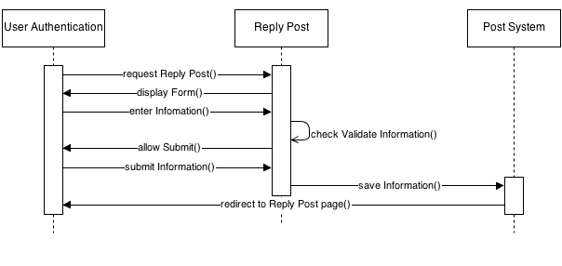

**7.8.4 Close Post**

|  |  |  |
| --- | --- | --- |
| **Author** | Phan Trong Nhan. | |
| **Use Case Name** | Close Post. | |
| **Actors** | User Authentication (Administrator, Worker, Customer, General public). | |
| **Description** | User Authentication who logged in website can close their own post. | |
| **Requirements** |  | |
| **Pre-conditions** | Actor has logged in System.  Actor has had post to edit. | |
| **Post-conditions** | Success: User close their own post, redirect to this Post. | |
| **Basic flow** | Actor Actions:  1. Actor choices and clicks post link.  3. Actor clicks on Close Post button.  5. Actor click ‘Yes’ button. [Alternative 1] | System Responses:  2. System redirects to Post page.  4. System display confirm dialog with notice :’Are you sure to close this post’.  6. System close this post, update database and show message: ‘Your post has been closed!’ and then redirects to this Post. |
| **Alternative flow** | Actor Actions:  [Alternative 1]  1. Actor click ‘Cancel’ button. | System Responses:  2. System close this dialog. |
| **Exception** |  |  |

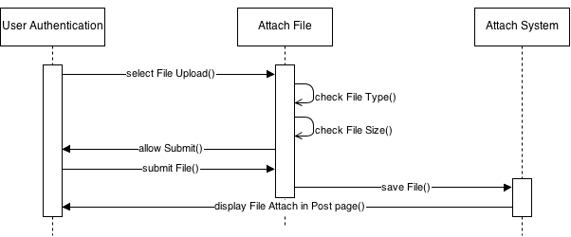

**7.8.5 Hidden Reply Post**

|  |  |  |
| --- | --- | --- |
| **Author** | Phan Trong Nhan. | |
| **Use Case Name** | Hidden Reply Post. | |
| **Actors** | User Authentication (Administrator, Worker, Customer, General public). | |
| **Description** | User Authentication who logged in website can hidden replies in their own post. | |
| **Requirements** | The reply have content disprove regulative. | |
| **Pre-conditions** | Actor has logged in System.  Actor has had their own post. | |
| **Post-conditions** | Success: Content of reply post will hidden, redirect to this Post.  Fail: Refill information. | |
| **Basic flow** | Actor Actions:  1. Actor choices and clicks their own post link.  3. Actor clicks on Report and Hidden Post button.  5. Actor click ‘Report and Hidden’ button. [Alternative 1] | System Responses:  2. System redirects to Post page.  4. System display Report Post form with the following control:  - ‘Type Report’ dropdown box.  - ‘Content’ text field.  6. System check the information. [Exception 1]  6. System close this dialog, update database and show message: ‘This reply has been hidden!’ and then redirects to this Post. |
| **Alternative flow** | Actor Actions:  [Alternative 1]  1. Actor click ‘Cancel’ button. | System Responses:  2. System close current dialog. |
| **Exception** | Actor Actions:  [Exception 1]  1. Actor don’t select item of dropdown box.  2. Actor leaves ‘Content’ text field blank. | System Responses:  System displays message to Actor :  - ‘Please select a Type Report!‘.  - ‘Please write a content for current problem!’. |

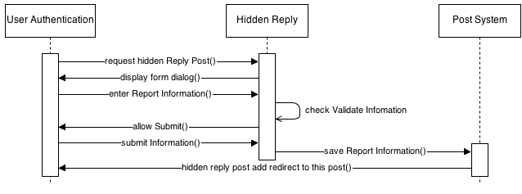

**7.8.6 Report Post**

|  |  |  |
| --- | --- | --- |
| **Author** | Phan Trong Nhan. | |
| **Use Case Name** | Report Post. | |
| **Actors** | User Authentication (Administrator, Worker, Customer, General public). | |
| **Description** | User Authentication who logged in website can report post. | |
| **Requirements** | The post have content disprove regulative. | |
| **Pre-conditions** | Actor has logged in System. | |
| **Post-conditions** | Success: Content of reply post will hidden, redirect to this Post.  Fail: Refill information. | |
| **Basic flow** | Actor Actions:  1. Actor views a post.  3. Actor clicks on Report Post button.  5. Actor click ‘Report’ button. [Alternative 1] | System Responses:  2. System redirects to Post page.  4. System display Report Post form dialog with the following control:  - ‘Type Report’ dropdown box.  - ‘Content’ text field.  6. System check the information. [Exception 1]  7. System close this dialog, update database and show message: ‘This report has been sent!’ and then redirects to this Post. |
| **Alternative flow** | Actor Actions:  [Alternative 1]  1. Actor click ‘Cancel’ button. | System Responses:  2. System close current dialog. |
| **Exception** | Actor Actions:  [Exception 1]  1. Actor don’t select item of dropdown box.  2. Actor leaves ‘Content’ text field blank. | System Responses:  System displays message to Actor :  - ‘Please select a Type Report!‘.  - ‘Please write a content for current problem!’. |

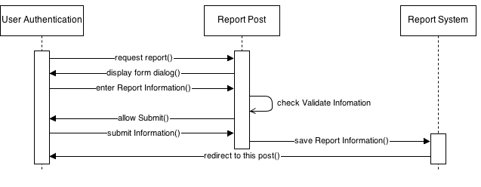

**7.8.7 Search Post**

|  |  |  |
| --- | --- | --- |
| **Author** | Phan Trong Nhan. | |
| **Use Case Name** | Report Post. | |
| **Actors** | User Authentication (Administrator, Worker, Customer, General public). | |
| **Description** | User Authentication who logged in website can search post. | |
| **Requirements** |  | |
| **Pre-conditions** | Actor has logged in System. | |
| **Post-conditions** | Success: Content of reply post will hidden, redirect to this Post.  Fail: Refill information. | |
| **Basic flow** | Actor Actions:  1. Actor input text in navigation menu and click on Search button.[Alternative 1] | System Responses:  2. System check the information. [Exception 1]  3. System redirect to Search page and display all result form text search. |
| **Alternative flow** | Actor Actions:  [Alternative 1]  1. Actor click ‘Back’ button. | System Responses:  2. System redirect to previous page. |
| **Exception** | Actor Actions:  [Exception 1]  1. Actor input text search unmatch with. | System Responses:  System displays message to Actor :  - ‘Data not found!‘. |

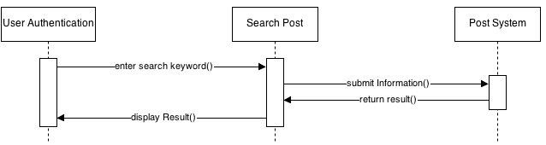

1. **Entity Relationship Diagram (ERD)**

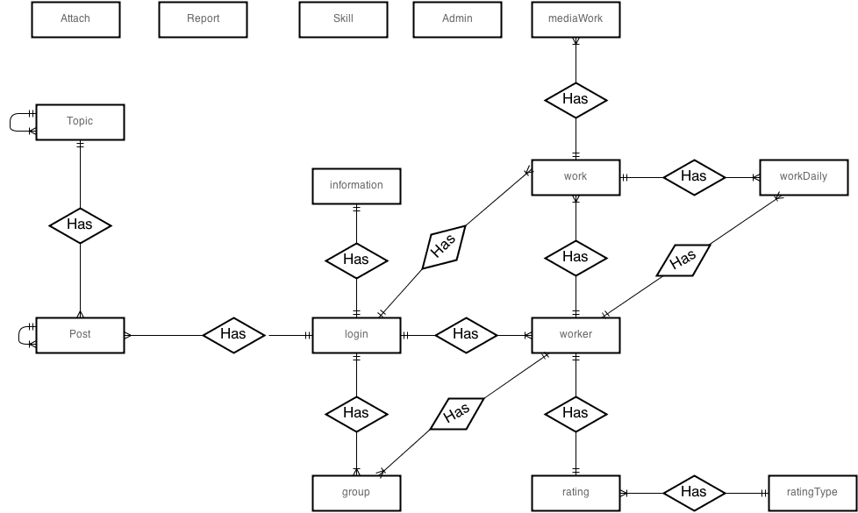**8.1 ERD**

**8.2 Table**

**8.2.1 Admin**

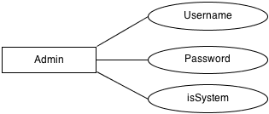

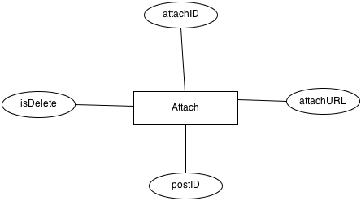 **8.2.2 Attach**

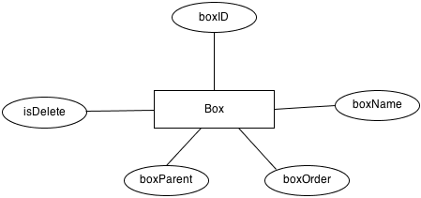 **8.2.3 Box**

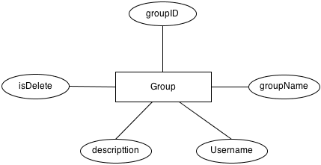 **8.2.4 Group**

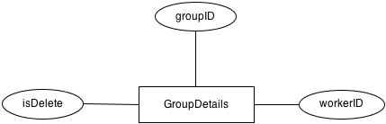 **8.2.5 GroupDetail**

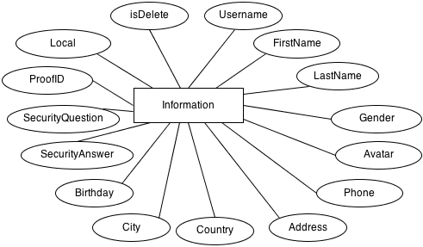 **8.2.6 Information**

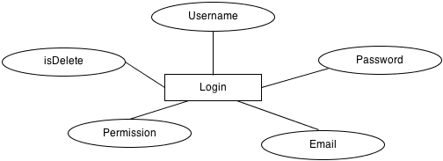 **8.2.7 Login**

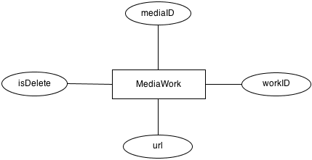 **8.2.8 MediaWork**

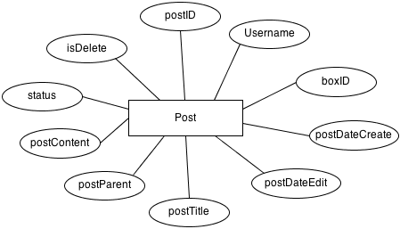 **8.2.9 Post**

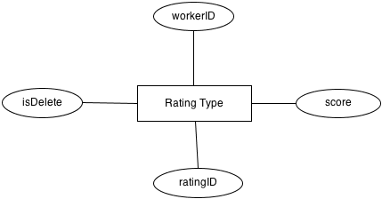 **8.2.10 Rating**

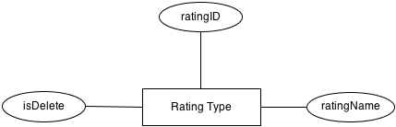 **8.2.11 RatingType**

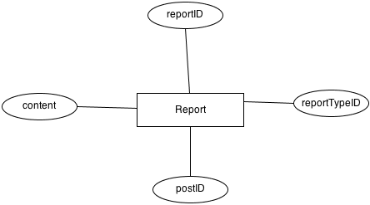 **8.2.12 Report**

**C:\Users\ChiTan\Desktop\entity table\reportType.png 8.2.13 ReportType**

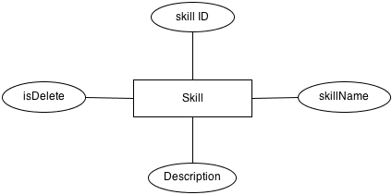 **8.2.14 Skill**

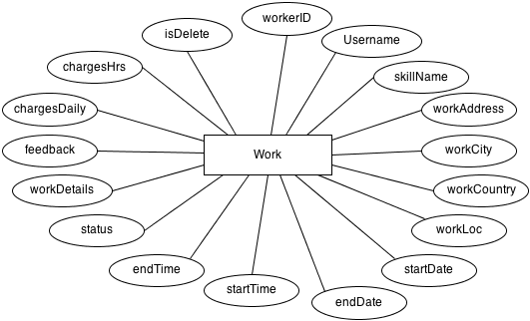 **8.2.15 Work**

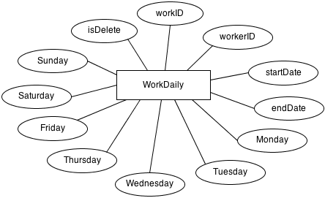 **8.2.16 WorkDaily**

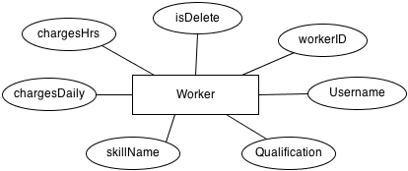 **8.2.17 Worker**

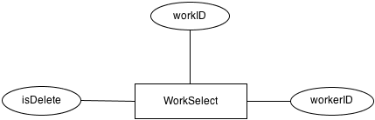 **8.2.18 WorkSelect**

|  |  |  |
| --- | --- | --- |
| **Date: Oct 3rd, 2013** | **Prepared by Project Group 3**  **Team Leader: Trinh Cong Thanh** | **Approved by**  **Mr : Ngo Phuoc Nguyen** |
| **Signature** |  |  |